**TABLE OF CONTENTS**

**CHAPTER 1 : INTRODUCTION Page No.**

* 1. Background 8-9

1.2 Objectives 9

1.3 Purpose & Scope 9-11

**CHAPTER 2: SURVEY OF TECHNOLOGIES**

2.1 Website 13

2.2 Web page 13

2.3 PHP 13-14

2.4 HTML 14-15

2.5 CSS 15

2.6 Java script 16

2.7 Bootstrap 16

2.8 Photoshop 16

2.9 Database 17

* MYSQL 17

2.10 Software 18

* WAMP SERVER 18
* SUBLIME TEXT 3 18

**CHAPTER 3 : REQUIREMENTYS & ANALYSIS 19**

3.1 Software & Hardware Requirement 20

3.2 Language used in website development 20

**CHAPTER 4 : SYSTEM DESIGN 21-26**

**CHAPTER 5 : TESTING AND RESULTS 27**

5.1Source Coding & Screenshots 28-71

**CHAPTER 6 : CONCLUSION 72**

6.1 Conclusion 73

6.2 future scope 73

6.3 Limitation of the project 73

**CHAPTER 7 : BIBLIOGRAPHY 74-75**

**CHAPTER 1:**

**INTRODUCTION**

**1.1 Background**

There are many such rural backward areas, which are deprived of many government facilities, such as electricity, roads, education, health facilities, drinking water supply, which is considered the most important for the development of any rural areas. The main purpose of our website is that we will give all the information about such areas which are deprived of development facilities. This will make it easier that the officers of the development departments will easily get information about such areas which actually need these facilities. With the help of this website, people of rural areas can show the problems of their area through the help of photos and videos.

Former President of India Late Abdul Kalam had dreamed of making India a developed country by 2020. Today he is not with us, but his dream is still in the heart of every Indian. It is also true that to make this dream come true, we have to bring not only our cities but also our villages on the path of development. India is mainly a country of villages. About 70 to 75 percent of India's population lives in villages. Ever since India got independence in 1947, the Indian and state governments have been working for the development of villages. Innumerable rural development schemes and projects were brought in over the last several decades but unfortunately, Indian villages are still facing many problems.

A village is a perfect place to live if we are in search of harmony with nature. Villages may appear green, serene, and pollution-free however life in these places can be quite challenging. People have everything for their minimum requirements of life. Villagers are just satisfied with the necessities of their living. They are always provided with fresh fruit, vegetables, fish, water, and clear air. There has been a lot of technological advancement in the last few decades. We are enjoying a comfortable life in the cities and have access to everything that due to the lack of modern facilities. Life in rural areas is thought to be slower-paced, resulting in lower levels of anxiety and a greater sense of relaxation. For these and other reasons, rural residents exhibit better mental health on the average than do urban residents.

**1.2 Objective**

In today's time, many schemes are given for the development of rural areas, whose full benefits are not available in rural areas. The main reason for which is that there are few people who come between the government and the constructor, who do not allow development works to be done properly. The reason for which is corruption, due to which the development work of that area is not done properly, nor do the investigating officers of the development department get the correct information about that work. With the help of this website, the correct information about the development works will be given by the people of that area through photos and videos clips. In today's time there are many such platforms like Facebook, Twitter, WhatsApp in which photos and videos of these problems are posted but due to lack of a special platform, these problems are ignored. The infrastructure in villages is not good. The roads and bridges are not built properly and this hampers their connectivity with towns and cities which is a hindrance in establishing good business. Schools and hospitals in the villages lack good staff as well as facilities. Many villages do not have a power supply or face a lot of power cuts. Communicating with people living in other areas can also get quite difficult for the villagers due to poor telecom infrastructure in these areas. Sanitation is another grave problem in villages.

**1.3 Purpose**

**Purpose**

Through **Gramin Digital Solution**, the people of the village can easily show their problems through photos or videos in our website.

For example, if the road of a village is bad, then you can make photos or videos of it, so that people will not have to go to the block or any office.

**Education should be Made Compulsory** The government must make education compulsory for everyone. Good schools should be opened in villages and the government should ensure that no child in any village remains uneducated.

**Adult Education** Adult education should also be promoted. Night schools must be opened for this purpose and adults must be encouraged to seek education. This is of utmost importance as only when the adults are educated they would understand the importance of education and educate their children.

**Roads must be Built** Roads and bridges should be built so that there is proper connectivity between the villages and cities. This will encourage the farmers and artisans to expand their business and make healthcare facilities easily approachable to villagers.

**Power Supply a Must** In today's times, it is impossible to grow and develop a region if there is no power supply or constant power cuts. This is one of the most basic things needed to progress in any field. Thus, the government must ensure that people in villages are not devoid of it.

**CHAPTER 2 :**

**SURVEY OF TECHNOLOGIES**

**2.1 Website**

Website is a collection of related web pages that may contain text, images, audio, and video, etc. The first page of a website is called a home page. Each website has a specific internet address (URL) that you need to enter in your browser to access a website.

A website is hosted on one or more servers and can be accessed by visiting its homepage using a computer network. A website is managed by its owner that can be an individual, company, or organization.

**2.2 Webpage**

A webpage is a document written in HTML and can be viewed on any web browser. It is contained within the web server, which can be accessed by entering the URL for that web page, and once it is loaded, it appears on the user's web browser. Each webpage is linked with a unique URL; hence two pages cannot have the same URL.

**2.3 PHP**

PHP sits between your browser and the web server. When you type in the URL of a PHP website in your browser, your browser sends out a request to the web server. The web server then calls the PHP script on

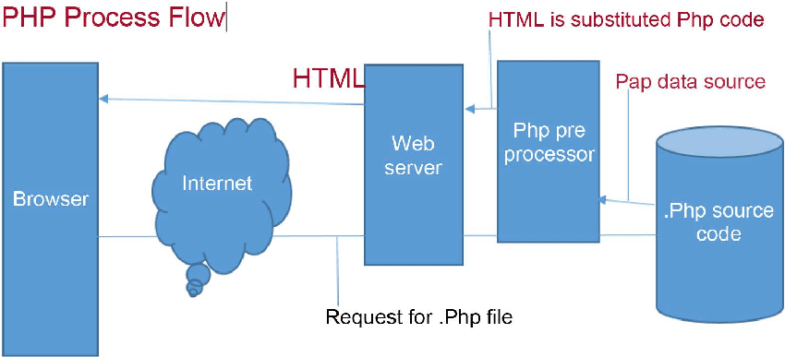

PHP is a server-side, cross-platform, HTML-embedded scripting language. There are over half a million domains running PHP and it is freely available for download. Much of PHP’ syntax is borrowed from C, Java and Perl with a couple of unique PHP specific features thrown in. The goal of the language is to allow web developers to write dynamically generated pages quickly. PHP eliminates the need for numerous small cgi programs by allowing you to place simple scripts directly in your HTML files.

It also makes it easier to manage large web sites by placing all components of a web page in a single html file. PHP is an excellent alternative to such similar programming solutions as Microsoft's proprietary scripting engine ASP and Allier’s rather expensive ColdFusion. As mentioned before, PHP is a cross-platform language. This doesn't stop with the core PHP code but can be extended to all of PHP's libraries and all code written in PHP. Neither ASP nor ColdFusion can make this claim. PHP has a large feature set which includes built-in support for numerous databases (including Access, LDAP, Oracle, and MSSQL), networking support, zip archiving, and an excellent set of built-in functions. Furthermore, due in part to it being open source and freely available for download on the web, the language enjoys an active developing environment. Since the syntax structure borrows heavily from C, it is easy for even the novice programmer to learn the language. PHP is also the oldest HTML-embedded scripting language, giving it a head start on all the others. If you are a content developer, you probably won’t want to learn PHP scripting by heart. But, it is nice to know how PHP can help you create more powerful web applications and user-friendly designs.

**2.4 HTML**

**Hyper Text Markup Language (HTML):-**

HTML, or Hyper Text Markup Language, has two essential features hypertext and universality. Hypertext means you can create a link in a Web page that leads the visitor to any other Web page or to practically anything else on the Internet. It means that the information on the Web can be accessed from many different directions. Tim Berners-Lee, the creator of the Web, wanted it to work more like a person's brain and less like a static source of data, such as a book. Universality means that because HTML documents are saved as Text Only files, virtually any computer can read a Web page. It doesn't matter if your visitors have Macintosh or Windows machines, or whether they're on a Unix box or even a handheld device like a Palm. The Web is open to all.

**Basic HTML Tags:**

<!-- --> specifies comments.

<A>…….</A> Creates hyper text links.

<B>……</B> Formats text as bold

<BIG>…….</BIG> Formats text in large font

<!DOCTYPE> define the document type.

<html> Define an HTML documents.

<title> Defines a title for the document.

<body> Defines the document body.

<p> Defines a paragraph.

<hr> Defines a thematic change in the content.

<head> Contain information for the document.

**2.5 CSS**

**C**ascading **S**tyle **S**heets, fondly referred to as CSS, is a simple design language intended to simplify the process of making web pages presentable.

CSS handles the look and feel part of a web page. Using CSS, you can control the color of the text, the style of fonts, the spacing between paragraphs, how columns are sized and laid out, what background images or colors are used, layout designs, variations in display for different devices and screen sizes as well as a variety of other effects.

CSS (Cascading Style Sheets) is a stylesheet language used to design the webpage to make it attractive. The reason for using this is to simplify the process of making web pages presentable. It allows you to apply styles to web pages. More importantly, it enables you to do this independent of the HTML that makes up each web page.

**2.6 Java Scripts**

JavaScript is a light-weight object-oriented programming language which is used by several websites for scripting the webpages. It is an interpreted, full-fledged programming language that enables dynamic interactivity on websites when applied to an HTML document. It was introduced in the year 1995 for adding programs to the webpages in the Netscape Navigator browser. Since then, it has been adopted by all other graphical web browsers. With JavaScript, users can build modern web applications to interact directly without reloading the page every time. The traditional website uses js to provide several forms of interactivity and simplicity.

**2.7 Bootstrap**

Bootstrap is a free and open-source tool collection for creating responsive websites and web applications. It is the most popular HTML, CSS, and JavaScript framework for developing responsive, mobile-first websites.

* Bootstrap is the most popular HTML, CSS and JavaScript framework for developing a responsive and mobile friendly website.
* It is absolutely free to download and use.
* It is a front-end framework used for easier and faster web development.
* It includes HTML and CSS based design templates for typography, forms, buttons, tables, navigation, modals, image carousels and many others.
* It can also use JavaScript plug-ins.
* It facilitates you to create responsive designs.

**2.8 Photoshop**

Photoshop is an exceptional raster-based photo editing software used for graphical work. It is primarily used to create, edit, and manipulate several graphical as well as digital artworks.

Photoshop is developed by **Adobe Systems** and provides support for windows and **Mac OS** operating systems.

**2.9 Database**

A database is a collection of data that is organized, which is also called structured data. It can be accessed or stored in a computer system. It can be managed through a Database Management System (DBMS), a software used to manage data. Database refers to related data in a structured form.

In a database, data is organized into tables consisting of rows and columns and it is indexed so data can be updated, expanded, and deleted easily. Computer databases typically contain file records data like transactions money in one bank account to another bank account, sales and customer details, fee details of students, and product details. There are different kinds of databases, ranging from the most prevalent approach, the relational database, to a distributed database, cloud database, and NoSQL databases.

**What is MYSQL**

**MySQL** server is a open-source relational database management system which is a major support for web based applications. Databases and related tables are the main component of many websites and applications as the data is stored and exchanged over the web. Even all social networking websites mainly Facebook, Twitter, and Google depends on MySQL data which are designed and optimized for such purpose. For all these reasons, MySQL server becomes the default choice for web applications.

MySQL server is used for data operations like querying, sorting, filtering, grouping, modifying and joining the tables.

**Advantages of MySQL:**

* Fast and high Performance database.
* Easy to use, maintain and administer.
* Easily available and maintain integrity of database.
* Provides scalability, usability and reliability.
* Low cost hardware.
* MySQL can read simple and complex queries and write operations.
* Provides strong indexing support.
* Provides SSL support for secured connections.
* Provides powerful data encryption and accuracy.
* Provides Cross-platform compatibility.
* Provides minimized code repetition.

**2.10 Software**

In a computer system, the software is basically a set of instructions or commands that tells a computer what to do. Or in other words, the software is a computer program that provides a set of instructions to execute a user’s commands and tell the computer what to do. For example like MS-Word, MS-Excel, PowerPoint, etc.

**What is Wampserver?**

**WampServer** is meant by constituting WAMP + SERVER, now here Wamp is a short form for “**Windows, Apache, MySQL and PHP**” whereas the Server simply means a Computer program that provides services to other applications or clients.

**What is Sublime text 3?**

Sublime text 3 (ST3) is a lightweight, cross-platform code editor known for its speed, ease of use, and strong community support.

**CHAPTER 3:**

**REQUIREMENT & ANALYSIS**

**3.1 Software Requirement & Hardware Requirement**

|  |  |  |
| --- | --- | --- |
| **Hardware Requirements** | | |
| **Processor** | **Hard-disk** | **Memory** |
| I3 or more | 50 GB & more | 1GB & more |
| **Software Requirement** | | |
| **Operating system** | **Database** | **Software** |
| Window latest version or  Old version. | MySQL | Sublime text 3,  Wamp Server |

**3.2 Language use in website development:**

HTML

CSS

PHP

BOOTSTRAP

JAVA SCRIPT

**CHAPTER 4 :**

**SYSTEM DESIGN**

**DATA FLOW DIAGRAM**

A data flow diagram (DFD) is a graphical representation of the “flow” of data through an information system. DFDs can be used for the visualization of data processing (structured design). On a DFD, data items flow from an external data source or an internal data store to an internal data store or an external data sink, via an internal process. A DFD provides no information about the timing or ordering of processes, or about processes will operate in sequence or in parallel. It is therefore quite different from a flowchart, which shows the flow of control through an algorithm, allowing a reader to determine what operations will be performed, in what order, and under what circumstances, but not what kinds of data will be input to and output from the system, nor where the data will come from and go to, nor where the data will be stored. DFDs are the model of the proposed system. They clearly should show the requirements on which the new system should be built. Later during design activity this is taken as the basis for drawing the system’s structure charts. The Basic Notation used to create a DFD’s are as follows:

**1. Dataflow:** Data move in a specific direction from an origin to a destination.

**2. Process:** People, procedures, or devices that use or produce (Transform) Data. The physical component is not identified.

**3. Source:** External sources or destination of data, which may be People, programs, organizations or other entities.

**4. Data Store:** Here data are stored or referenced by a process in the System.

**DFD Context Level**

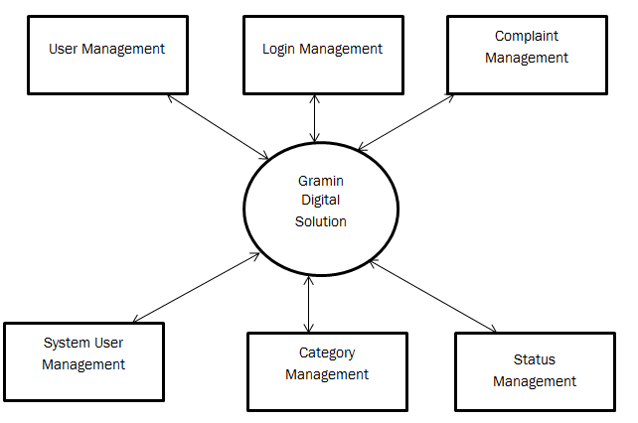

**DFD 1 LEVEL**

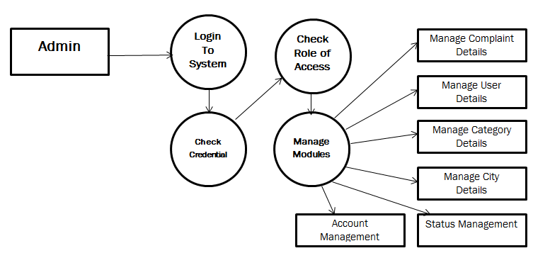

**DFD 2 LEVEL**

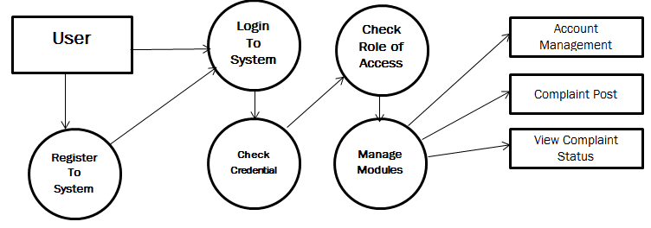

**ER Diagram**

**ER Diagram** stands for Entity Relationship Diagram, also known as ERD is a diagram that displays the relationship of entity sets stored in a database. In other words, ER diagrams help to explain the logical structure of databases. ER diagrams are created based on three basic concepts: entities, attributes and relationships.

ER Diagrams contain different symbols that use rectangles to represent entities, ovals to define attributes and diamond shapes to represent relationships.

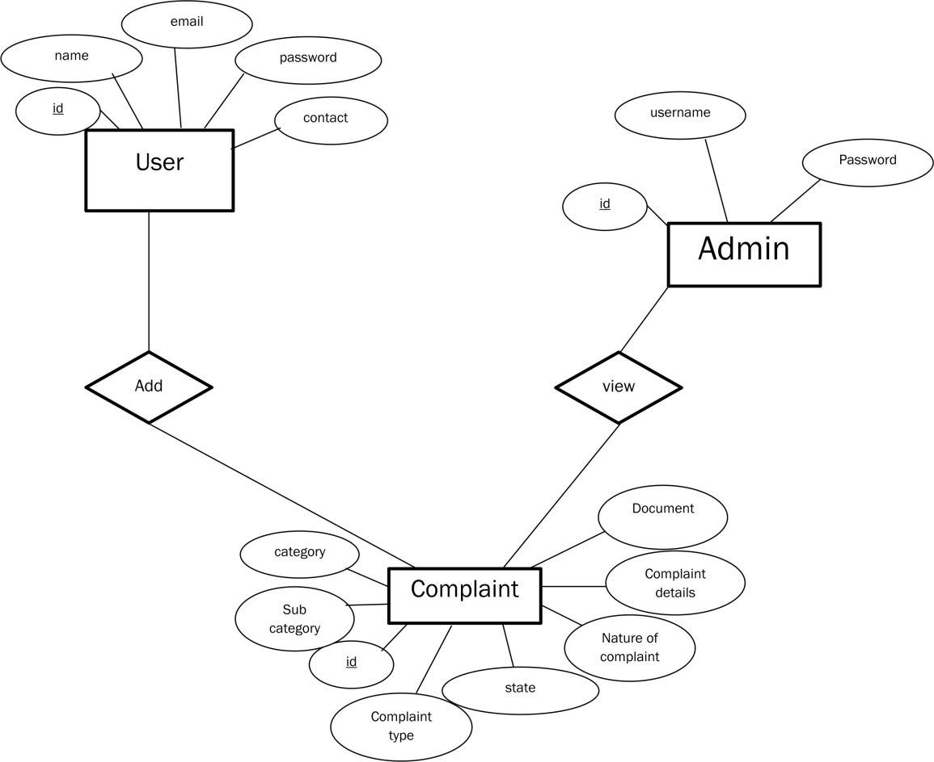

**CHAPTER 5:**

**TESTING AND SCREENSHOTS**

**Coding and Screenshots**

**Homepage**

**(header.php)**

**<!DOCTYPE html>**

**<html lang="en">**

**<head>**

**<meta charset="utf-8">**

**<meta http-equiv="X-UA-Compatible" content="IE=edge">**

**<meta name="viewport" content="width=device-width, initial-scale=1">**

**<meta name="description" content="">**

**<meta name="author" content="">**

**<title>Gramin Digital Solutions</title>**

**<link href="css/bootstrap.min.css" rel="stylesheet">**

**<link rel="stylesheet" href="https://cdnjs.cloudflare.com/ajax/libs/font-awesome/4.7.0/css/font-awesome.min.css">**

**<link href="css/half-slider.css" rel="stylesheet">**

**<link rel="stylesheet" href="https://maxcdn.bootstrapcdn.com/bootstrap/3.4.1/css/bootstrap.min.css">**

**<script src="https://ajax.googleapis.com/ajax/libs/jquery/3.6.0/jquery.min.js"></script>**

**<script src="https://maxcdn.bootstrapcdn.com/bootstrap/3.4.1/js/bootstrap.min.js"></script>**

**</head>**

**<body>**

**<!-- Navigation -->**

**<nav class="navbar navbar-inverse navbar-fixed-top" role="navigation">**

**<div class="container">**

**<!-- Brand and toggle get grouped for better mobile display -->**

**<div class="navbar-header">**

**<button type="button" class="navbar-toggle" data-toggle="collapse" data-target="#bs-example-navbar-collapse-1">**

**<span class="sr-only">Toggle navigation</span>**

**<span class="icon-bar"></span>**

**<span class="icon-bar"></span>**

**<span class="icon-bar"></span>**

**</button>**

**<a class="navbar-brand" href="#">Gramin Digital Solutions</a>**

**</div>**

**<!-- Collect the nav links, forms, and other content for toggling -->**

**<div class="collapse navbar-collapse" id="bs-example-navbar-collapse-1">**

**<ul class="nav navbar-nav">**

**<li>**

**<a href="index.php">Home</a>**

**</li>**

**<li>**

**<a href="contact.php">Contact</a>**

**</li>**

**<li>**

**<a href="users/">User Login</a>**

**</li>**

**<li>**

**<a href="users/registration.php">User Registration</a>**

**</li>**

**<li>**

**<a href="admin/">Admin</a>**

**</li>**

**</ul>**

**</div>**

**<!-- /.navbar-collapse -->**

**</div>**

**<!-- /.container -->**

**</nav>**

**(index.php)**

<?php include "header.php"; ?>

<div id="myCarousel" class="carousel slide" data-ride="carousel" style="padding-top: 40px">

<!-- Indicators -->

<ol class="carousel-indicators">

<li data-target="#myCarousel" data-slide-to="0" class="active"></li>

<li data-target="#myCarousel" data-slide-to="1"></li>

<li data-target="#myCarousel" data-slide-to="2"></li>

</ol>

<!-- Wrapper for slides -->

<div class="carousel-inner">

<div class="item active">

<img src="img/2.jpg" style="width: 100%; height: 450px">

</div>

<div class="item">

<img src="img/c1.jpg" style="width: 100%; height: 450px">

</div>

<div class="item">

<img src="img/c2.png" style="width: 100%; height: 450px">

</div>

</div>

<!-- Left and right controls -->

<a class="left carousel-control" href="#myCarousel" data-slide="prev">

<span class="glyphicon glyphicon-chevron-left"></span>

<span class="sr-only">Previous</span>

</a>

<a class="right carousel-control" href="#myCarousel" data-slide="next">

<span class="glyphicon glyphicon-chevron-right"></span>

<span class="sr-only">Next</span>

</a>

</div>

<!-- Page Content -->

<div class="container" style="padding-top: 30px">

<div class="row">

<div class="col-lg-6">

<h3><b>Gramin Digital Solutions</b></h3>

<p></p>

</div>

<div class="col-lg-2">

<center><img src="img/11.jpg" style="border-radius: 50%">

<h5><b>Shri Ramesh Bais<br><span style="font-size: 12px">Governor</span></b></h5>

</center>

</div>

<div class="col-lg-2">

<center><img src="img/12.jpg" style="border-radius: 50%">

<h5><b>Shri Hemant Soren<br><span style="font-size: 12px">Chief Minister</span></b></h5>

</center>

</div>

<div class="col-lg-2">

<center><img src="img/13.jpg" style="border-radius: 50%">

<h5><b>Shri Sukhdeo Singh<br><span style="font-size: 12px">Chief Secretary</span></b></h5>

</center>

</div>

</div>

<hr>

<!-- Footer -->

<footer>

<div class="row">

<div class="col-lg-12">

<b class="copyright">&copy; 2022 Gramin Digital Solutions </b> All rights reserved.

</div>

</div>

</footer>

</div>

<!-- /.container -->

<!-- jQuery -->

<script src="js/jquery.js"></script>

<!-- Bootstrap Core JavaScript -->

<script src="js/bootstrap.min.js"></script>

<!-- Script to Activate the Carousel -->

<script>

$('.carousel').carousel({

interval: 5000 //changes the speed

})

</script>

</body>

</html>

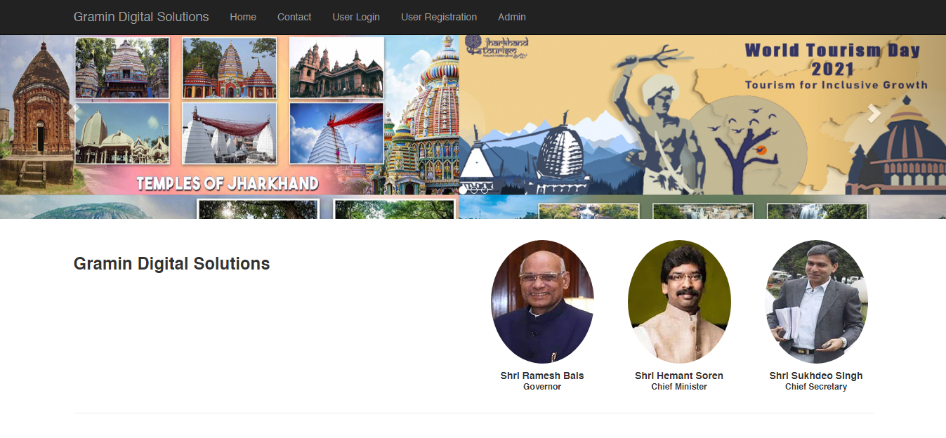

**Contact Us Page (contact.php)**

<?php include "header.php";

$con=mysqli_connect("localhost","root","","cms");

if(isset($_POST['send']))

{

$a=$_POST['t1'];

$b=$_POST['t2'];

$c=$_POST['t3'];

$d=$_POST['t4'];

$e=$_POST['t5'];

$in=mysqli_query($con,"insert into contact(name,mobile,email,subject,message) values('$a','$b','$c','$d','$e')");

if($in)

{

echo "<script>alert('Thanks for your message...');</script>";

echo "<script>window.location='index.php';</script>";

}

}

?>

<title>Contact us</title>

<div class="container-fluid" style="padding-top: 40px">

<div class="row">

<div class="col-md-6">

<div class="page-header">

<h1 align="center">Contact Us</h1>

</div>

<div class="jumbotron">

<p><i class="fa fa-home"></i> Ranchi, Jharkhand - 834005</p>

<p><i class="fa fa-phone"></i> +91 1234567890, 1800-1234-4567</p>

<p><i class="fa fa-envelope"></i> info@gramindigitalsolutions.in</p>

</div>

</div>

<div class="container"><div class="col-md-6">

<div class="page-header">

<h1 align="center">Message Us</h1> </div>

<form method="post">

<label><b>Name</b></label>

<input type="text" name="t1" class="form-control" required="required" pattern="[A-Za-z ]{3,}" placeholder="Enter Name"><label><b>Mobile Number</b></label>

<input type="text" name="t2" class="form-control" required="required" pattern="[0-9]{10}" placeholder="Enter Mobile Number">

<label><b>Email ID</b></label>

<input type="email" name="t3" class="form-control" required="required" placeholder="Enter Email ID">

<label><b>Subject</b></label>

<input type="text" name="t4" class="form-control" required="required" pattern="[A-Za-z ]{3,}" placeholder="Subjects">

<label>&nbsp;</label>

<textarea class="form-control" name="t5" rows="3" placeholder="Message"></textarea>

<br>

<input type="submit" name="send" class="btn btn-success" style="float: right">

</form></div></div></div> </div>

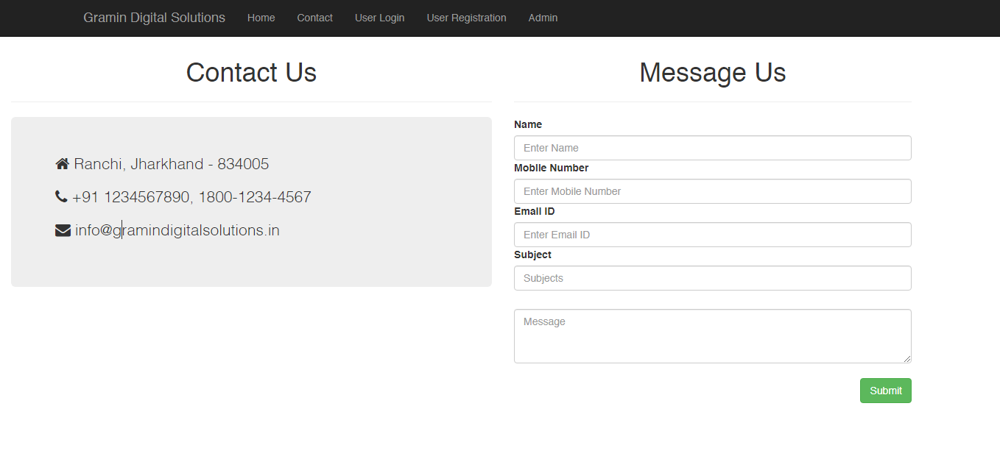

**User Registration (registration.php)**

<?php

include('includes/config.php');

error_reporting(0);

if(isset($_POST['submit']))

{

$fullname=$_POST['fullname'];

$email=$_POST['email'];

$password=md5($_POST['password']);

$contactno=$_POST['contactno'];

$status=1;

$query=mysqli_query($con,"insert into users(fullName,userEmail,password,contactNo,status) values('$fullname','$email','$password','$contactno','$status')");

$msg="Registration successfull. Now You can login !";

}

?>

<!DOCTYPE html>

<html lang="en">

<head>

<meta charset="utf-8">

<meta name="viewport" content="width=device-width, initial-scale=1.0">

<meta name="description" content="">

<meta name="author" content="Dashboard">

<meta name="keyword" content="Dashboard, Bootstrap, Admin, Template, Theme, Responsive, Fluid, Retina">

<title>CMS | User Registration</title>

<link href="assets/css/bootstrap.css" rel="stylesheet">

<link href="assets/font-awesome/css/font-awesome.css" rel="stylesheet" />

<link href="assets/css/style.css" rel="stylesheet">

<link href="assets/css/style-responsive.css" rel="stylesheet">

<script>

function userAvailability() {

$("#loaderIcon").show();

jQuery.ajax({

url: "check_availability.php",

data:'email='+$("#email").val(),

type: "POST",

success:function(data){

$("#user-availability-status1").html(data);

$("#loaderIcon").hide();

},

error:function (){}

});

}

</script>

</head>

<body>

<div id="login-page">

<div class="container">

<h3 align="center" style="color:#fff">Gramin Digital Solutions</h3>

<hr />

<form class="form-login" method="post">

<h2 class="form-login-heading">User Registration</h2>

<p style="padding-left: 1%; color: green">

<?php if($msg){

echo htmlentities($msg);

}?>

</p>

<div class="login-wrap">

<input type="text" class="form-control" placeholder="Full Name" name="fullname" required="required" autofocus>

<br>

<input type="email" class="form-control" placeholder="Email ID" id="email" onBlur="userAvailability()" name="email" required="required">

<span id="user-availability-status1" style="font-size:12px;"></span>

<br>

<input type="password" class="form-control" placeholder="Password" required="required" name="password"><br >

<input type="text" class="form-control" maxlength="10" name="contactno" placeholder="Contact no" required="required" autofocus>

<br>

<button class="btn btn-theme btn-block" type="submit" name="submit" id="submit"><i class="fa fa-user"></i> Register</button>

<hr>

<div class="registration">

Already Registered<br/>

<a class="" href="index.php">

Sign in

</a>

</div>

</div>

</form>

</div>

</div>

<!-- js placed at the end of the document so the pages load faster -->

<script src="assets/js/jquery.js"></script>

<script src="assets/js/bootstrap.min.js"></script>

<!--BACKSTRETCH-->

<!-- You can use an image of whatever size. This script will stretch to fit in any screen size.-->

<script type="text/javascript" src="assets/js/jquery.backstretch.min.js"></script>

<script>

$.backstretch("assets/img/login-bg.jpg", {speed: 500});

</script>

</body>

</html>

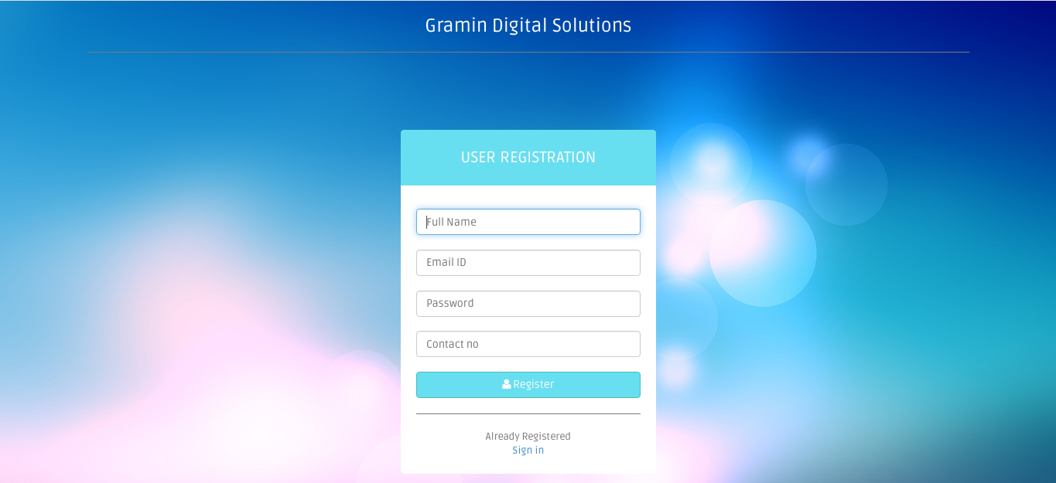

**User Login (users/index.php)**

<?php

session_start();

error_reporting(0);

include("includes/config.php");

if(isset($_POST['submit']))

{

$ret=mysqli_query($con,"SELECT * FROM users WHERE userEmail='".$_POST['username']."' and password='".md5($_POST['password'])."'");

$num=mysqli_fetch_array($ret);

if($num>0)

{

$extra="dashboard.php";//

$_SESSION['login']=$_POST['username'];

$_SESSION['id']=$num['id'];

$host=$_SERVER['HTTP_HOST'];

$uip=$_SERVER['REMOTE_ADDR'];

$status=1;

$log=mysqli_query($con,"insert into userlog(uid,username,userip,status) values('".$_SESSION['id']."','".$_SESSION['login']."','$uip','$status')");

$uri=rtrim(dirname($_SERVER['PHP_SELF']),'/\\');

header("location:http://$host$uri/$extra");

exit();

}

else

{

$_SESSION['login']=$_POST['username'];

$uip=$_SERVER['REMOTE_ADDR'];

$status=0;

mysqli_query($con,"insert into userlog(username,userip,status) values('".$_SESSION['login']."','$uip','$status')");

$errormsg="Invalid username or password";

$extra="login.php";

}

}

if(isset($_POST['change']))

{

$email=$_POST['email'];

$contact=$_POST['contact'];

$password=md5($_POST['password']);

$query=mysqli_query($con,"SELECT * FROM users WHERE userEmail='$email' and contactNo='$contact'");

$num=mysqli_fetch_array($query);

if($num>0)

{

mysqli_query($con,"update users set password='$password' WHERE userEmail='$email' and contactNo='$contact' ");

$msg="Password Changed Successfully";

}

else

{

$errormsg="Invalid email id or Contact no";

}

}

?>

<!DOCTYPE html>

<html lang="en">

<head>

<meta charset="utf-8">

<meta name="viewport" content="width=device-width, initial-scale=1.0">

<meta name="description" content="">

<meta name="author" content="Dashboard">

<meta name="keyword" content="Dashboard, Bootstrap, Admin, Template, Theme, Responsive, Fluid, Retina">

<title>CMS | User Login</title>

<!-- Bootstrap core CSS -->

<link href="assets/css/bootstrap.css" rel="stylesheet">

<!--external css-->

<link href="assets/font-awesome/css/font-awesome.css" rel="stylesheet" />

<!-- Custom styles for this template -->

<link href="assets/css/style.css" rel="stylesheet">

<link href="assets/css/style-responsive.css" rel="stylesheet">

<script type="text/javascript">

function valid()

{

if(document.forgot.password.value!= document.forgot.confirmpassword.value)

{

alert("Password and Confirm Password Field do not match !!");

document.forgot.confirmpassword.focus();

return false;

}

return true;

}

</script>

</head>

<body>

<!-- **********************************************************************************************************************************************************

MAIN CONTENT

*********************************************************************************************************************************************************** -->

<div id="login-page">

<div class="container">

<h3 align="center" style="color:#fff">Gramin Digital Solutions</h3>

<hr />

<form class="form-login" name="login" method="post">

<h2 class="form-login-heading">sign in now</h2>

<p style="padding-left:4%; padding-top:2%; color:red">

<?php if($errormsg){

echo htmlentities($errormsg);

}?></p>

<p style="padding-left:4%; padding-top:2%; color:green">

<?php if($msg){

echo htmlentities($msg);

}?></p>

<div class="login-wrap">

<input type="text" class="form-control" name="username" placeholder="User ID" required autofocus>

<br>

<input type="password" class="form-control" name="password" required placeholder="Password">

<label class="checkbox">

<span class="pull-right">

<a data-toggle="modal" href="login.html#myModal"> Forgot Password?</a>

</span>

</label>

<button class="btn btn-theme btn-block" name="submit" type="submit"><i class="fa fa-lock"></i> SIGN IN</button>

<hr>

</form>

<div class="registration">

Don't have an account yet?<br/>

<a class="" href="registration.php">

Create an account

</a>

</div>

</div>

<!-- Modal -->

<form class="form-login" name="forgot" method="post">

<div aria-hidden="true" aria-labelledby="myModalLabel" role="dialog" tabindex="-1" id="myModal" class="modal fade">

<div class="modal-dialog">

<div class="modal-content">

<div class="modal-header">

<button type="button" class="close" data-dismiss="modal" aria-hidden="true">&times;</button>

<h4 class="modal-title">Forgot Password ?</h4>

</div>

<div class="modal-body">

<p>Enter your details below to reset your password.</p>

<input type="email" name="email" placeholder="Email" autocomplete="off" class="form-control" required><br >

<input type="text" name="contact" placeholder="contact No" autocomplete="off" class="form-control" required><br>

<input type="password" class="form-control" placeholder="New Password" id="password" name="password" required ><br />

<input type="password" class="form-control unicase-form-control text-input" placeholder="Confirm Password" id="confirmpassword" name="confirmpassword" required >

</div>

<div class="modal-footer">

<button data-dismiss="modal" class="btn btn-default" type="button">Cancel</button>

<button class="btn btn-theme" type="submit" name="change" onclick="return valid();">Submit</button>

</div>

</div>

</div>

</div>

<!-- modal -->

</form>

</div>

</div>

<!-- js placed at the end of the document so the pages load faster -->

<script src="assets/js/jquery.js"></script>

<script src="assets/js/bootstrap.min.js"></script>

<!--BACKSTRETCH-->

<!-- You can use an image of whatever size. This script will stretch to fit in any screen size.-->

<script type="text/javascript" src="assets/js/jquery.backstretch.min.js"></script>

<script>

$.backstretch("assets/img/login-bg.jpg", {speed: 500});

</script>

</body>

</html>

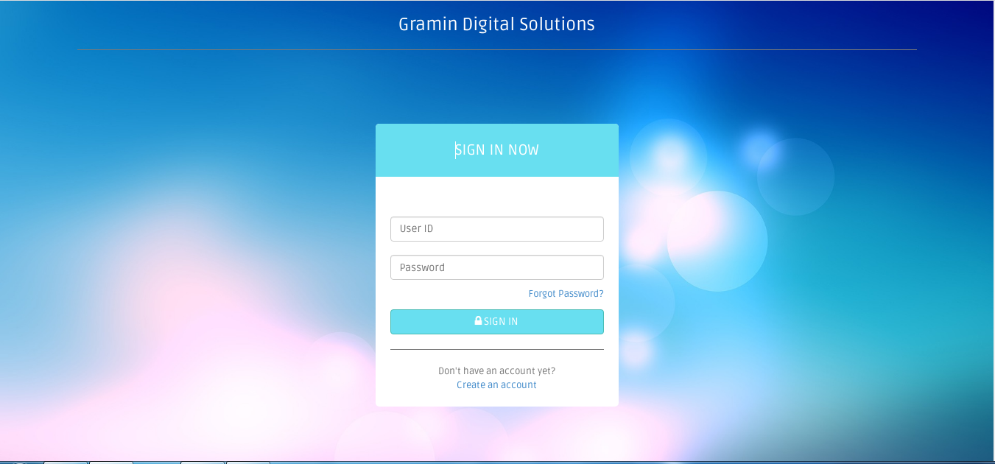

**Admin Login (admin/index.php)**

<?php

session_start();

error_reporting(0);

include("include/config.php");

if(isset($_POST['submit']))

{

$username=$_POST['username'];

$password=md5($_POST['password']);

$ret=mysqli_query($con,"SELECT * FROM admin WHERE username='$username' and password='$password'");

$num=mysqli_fetch_array($ret);

if($num>0)

{

$extra="change-password.php";//

$_SESSION['alogin']=$_POST['username'];

$_SESSION['id']=$num['id'];

$host=$_SERVER['HTTP_HOST'];

$uri=rtrim(dirname($_SERVER['PHP_SELF']),'/\\');

header("location:http://$host$uri/$extra");

exit();

}

else

{

$_SESSION['errmsg']="Invalid username or password";

$extra="index.php";

$host = $_SERVER['HTTP_HOST'];

$uri = rtrim(dirname($_SERVER['PHP_SELF']),'/\\');

header("location:http://$host$uri/$extra");

exit();

}

}

?>

<!DOCTYPE html>

<html lang="en">

<head>

<meta http-equiv="Content-Type" content="text/html; charset=utf-8" />

<meta name="viewport" content="width=device-width, initial-scale=1.0">

<title>CMS | Admin login</title>

<link type="text/css" href="bootstrap/css/bootstrap.min.css" rel="stylesheet">

<link type="text/css" href="bootstrap/css/bootstrap-responsive.min.css" rel="stylesheet">

<link type="text/css" href="css/theme.css" rel="stylesheet">

<link type="text/css" href="images/icons/css/font-awesome.css" rel="stylesheet">

<link type="text/css" href='http://fonts.googleapis.com/css?family=Open+Sans:400italic,600italic,400,600' rel='stylesheet'>

</head>

<body>

<div class="navbar navbar-fixed-top">

<div class="navbar-inner">

<div class="container">

<a class="btn btn-navbar" data-toggle="collapse" data-target=".navbar-inverse-collapse">

<i class="icon-reorder shaded"></i>

</a>

<a class="brand" href="../">

Gramin Digital Solution | Admin

</a>

<div class="nav-collapse collapse navbar-inverse-collapse">

<ul class="nav pull-right">

<li><a href="../">

Back to Portal

</a></li>

</ul>

</div><!-- /.nav-collapse -->

</div>

</div><!-- /navbar-inner -->

</div><!-- /navbar -->

<div class="wrapper">

<div class="container">

<div class="row">

<div class="module module-login span4 offset4">

<form class="form-vertical" method="post">

<div class="module-head">

<h3>Sign In</h3>

</div>

<span style="color:red;" ><?php echo htmlentities($_SESSION['errmsg']); ?><?php echo htmlentities($_SESSION['errmsg']="");?></span>

<div class="module-body">

<div class="control-group">

<div class="controls row-fluid">

<input class="span12" type="text" id="inputEmail" name="username" placeholder="Username">

</div>

</div>

<div class="control-group">

<div class="controls row-fluid">

<input class="span12" type="password" id="inputPassword" name="password" placeholder="Password">

</div>

</div>

</div>

<div class="module-foot">

<div class="control-group">

<div class="controls clearfix">

<button type="submit" class="btn btn-primary pull-right" name="submit">Login</button>

</div>

</div>

</div>

</form>

</div>

</div>

</div>

</div><!--/.wrapper-->

<script src="scripts/jquery-1.9.1.min.js" type="text/javascript"></script>

<script src="scripts/jquery-ui-1.10.1.custom.min.js" type="text/javascript"></script>

<script src="bootstrap/js/bootstrap.min.js" type="text/javascript"></script>

</body>

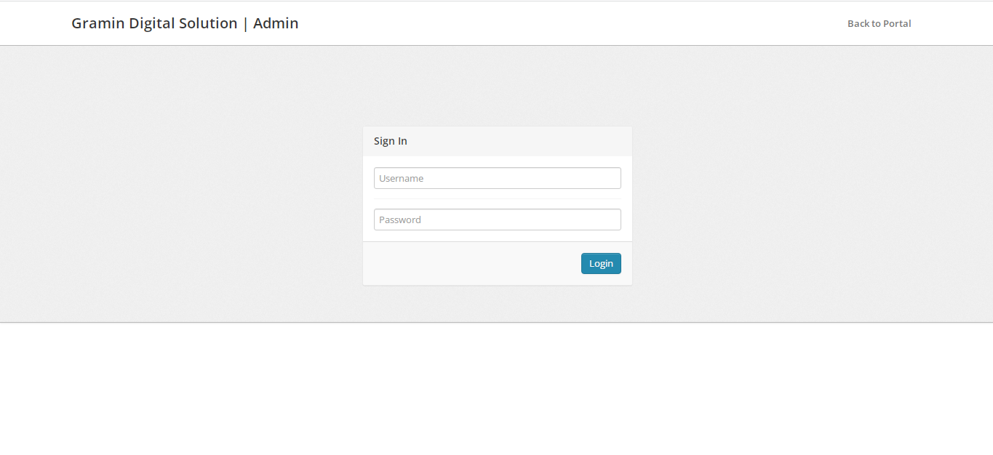

**Admin Change Password (admin/change_password.php)**

<?php

session_start();

include('include/config.php');

if(strlen($_SESSION['alogin'])==0)

{

header('location:index.php');

}

else{

date_default_timezone_set('Asia/Kolkata');// change according timezone

$currentTime = date( 'd-m-Y h:i:s A', time () );

if(isset($_POST['submit']))

{

$sql=mysqli_query($con,"SELECT password FROM admin where password='".md5($_POST['password'])."' && username='".$_SESSION['alogin']."'");

$num=mysqli_fetch_array($sql);

if($num>0)

{

$con=mysqli_query($con,"update admin set password='".md5($_POST['newpassword'])."', updationDate='$currentTime' where username='".$_SESSION['alogin']."'");

$_SESSION['msg']="Password Changed Successfully !!";

}

else

{

$_SESSION['msg']="Old Password not match !!";

}

}

?>

<!DOCTYPE html>

<html lang="en">

<head>

<meta http-equiv="Content-Type" content="text/html; charset=utf-8" />

<meta name="viewport" content="width=device-width, initial-scale=1.0">

<title>Admin| Change Password</title>

<link type="text/css" href="bootstrap/css/bootstrap.min.css" rel="stylesheet">

<link type="text/css" href="bootstrap/css/bootstrap-responsive.min.css" rel="stylesheet">

<link type="text/css" href="css/theme.css" rel="stylesheet">

<link type="text/css" href="images/icons/css/font-awesome.css" rel="stylesheet">

<link type="text/css" href='http://fonts.googleapis.com/css?family=Open+Sans:400italic,600italic,400,600' rel='stylesheet'>

<script type="text/javascript">

function valid()

{

if(document.chngpwd.password.value=="")

{

alert("Current Password Filed is Empty !!");

document.chngpwd.password.focus();

return false;

}

else if(document.chngpwd.newpassword.value=="")

{

alert("New Password Filed is Empty !!");

document.chngpwd.newpassword.focus();

return false;

}

else if(document.chngpwd.confirmpassword.value=="")

{

alert("Confirm Password Filed is Empty !!");

document.chngpwd.confirmpassword.focus();

return false;

}

else if(document.chngpwd.newpassword.value!= document.chngpwd.confirmpassword.value)

{

alert("Password and Confirm Password Field do not match !!");

document.chngpwd.confirmpassword.focus();

return false;

}

return true;

}

</script>

</head>

<body>

<?php include('include/header.php');?>

<div class="wrapper">

<div class="container">

<div class="row">

<?php include('include/sidebar.php');?>

<div class="span9">

<div class="content">

<div class="module">

<div class="module-head"><h3>Admin Change Password</h3></div>

<div class="module-body">

<?php if(isset($_POST['submit']))

{?> <div class="alert alert-success">

<button type="button" class="close" data-dismiss="alert">×</button>

<?php echo htmlentities($_SESSION['msg']);?>

<?php echo htmlentities($_SESSION['msg']="");?> </div>

<?php } ?><br />

<form class="form-horizontal row-fluid" name="chngpwd" method="post" onSubmit="return valid();">

<div class="control-group">

<label class="control-label" for="basicinput">Current Password</label>

<div class="controls">

<input type="password" placeholder="Enter your current Password" name="password" class="span8 tip" required>

</div>

</div>

<div class="control-group">

<label class="control-label" for="basicinput">New Password</label>

<div class="controls">

<input type="password" placeholder="Enter your new current Password" name="newpassword" class="span8 tip" required>

</div>

</div>

<div class="control-group">

<label class="control-label" for="basicinput">Current Password</label>

<div class="controls">

<input type="password" placeholder="Enter your new Password again" name="confirmpassword" class="span8 tip" required>

</div>

</div>

<div class="control-group">

<div class="controls">

<button type="submit" name="submit" class="btn">Submit</button>

</div>

</div>

</form>

</div>

</div>

</div><!--/.content-->

</div><!--/.span9-->

</div>

</div><!--/.container-->

</div><!--/.wrapper-->

<?php include('include/footer.php');?>

<script src="scripts/jquery-1.9.1.min.js" type="text/javascript"></script>

<script src="scripts/jquery-ui-1.10.1.custom.min.js" type="text/javascript"></script>

<script src="bootstrap/js/bootstrap.min.js" type="text/javascript"></script>

<script src="scripts/flot/jquery.flot.js" type="text/javascript"></script>

</body>

<?php } ?>

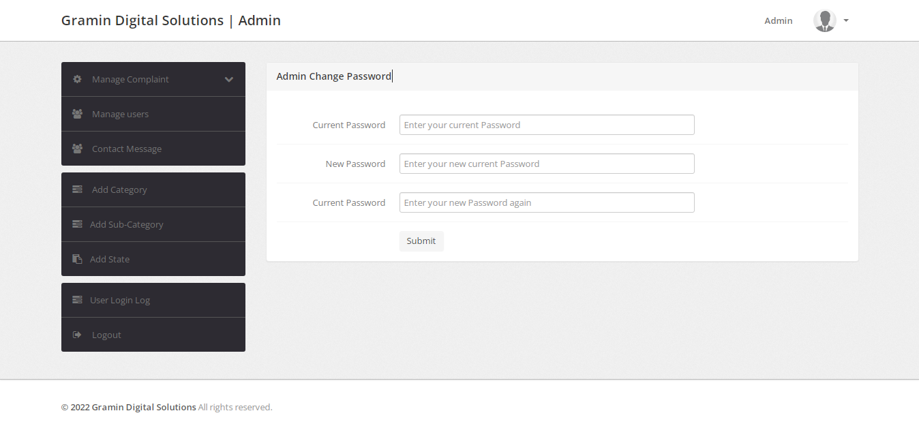

**User Dashboard (dashboard.php)**

<?php session_start();

error_reporting(0);

include('includes/config.php');

if(strlen($_SESSION['login'])==0)

{

header('location:index.php');

}

else{ ?>

<!DOCTYPE html>

<html lang="en">

<head>

<meta charset="utf-8">

<meta name="viewport" content="width=device-width, initial-scale=1.0">

<meta name="description" content="">

<meta name="author" content="Dashboard">

<meta name="keyword" content="Dashboard, Bootstrap, Admin, Template, Theme, Responsive, Fluid, Retina">

<title>CMS | Dashboard</title>

<!-- Bootstrap core CSS -->

<link href="assets/css/bootstrap.css" rel="stylesheet">

<!--external css-->

<link href="assets/font-awesome/css/font-awesome.css" rel="stylesheet" />

<link rel="stylesheet" type="text/css" href="assets/css/zabuto_calendar.css">

<link rel="stylesheet" type="text/css" href="assets/js/gritter/css/jquery.gritter.css" />

<link rel="stylesheet" type="text/css" href="assets/lineicons/style.css">

<!-- Custom styles for this template -->

<link href="assets/css/style.css" rel="stylesheet">

<link href="assets/css/style-responsive.css" rel="stylesheet">

<script src="assets/js/chart-master/Chart.js"></script>

<!-- HTML5 shim and Respond.js IE8 support of HTML5 elements and media queries -->

<!--[if lt IE 9]>

<script src="https://oss.maxcdn.com/libs/html5shiv/3.7.0/html5shiv.js"></script>

<script src="https://oss.maxcdn.com/libs/respond.js/1.4.2/respond.min.js"></script>

<![endif]-->

</head>

<body>

<section id="container" >

<?php include("includes/header.php");?>

<?php include("includes/sidebar.php");?>

<section id="main-content">

<section class="wrapper">

<div class="row">

<div class="col-lg-9 main-chart">

<div class="col-md-2 col-sm-2 box0">

<div>

</div></div>

<div class="col-md-2 col-sm-2 box0">

<div class="box1">

<span class="li_news"></span>

<?php

$rt = mysqli_query($con,"SELECT * FROM tblcomplaints where userId='".$_SESSION['id']."' and status is null");

$num1 = mysqli_num_rows($rt);

{?>

<h3><?php echo htmlentities($num1);?></h3>

</div>

<p><?php echo htmlentities($num1);?> Complaints not Process yet</p>

</div>

<?php }?>

<div class="col-md-2 col-sm-2 box0">

<div class="box1">

<span class="li_news"></span>

<?php

$status="in Process";

$rt = mysqli_query($con,"SELECT * FROM tblcomplaints where userId='".$_SESSION['id']."' and status='$status'");

$num1 = mysqli_num_rows($rt);

{?>

<h3><?php echo htmlentities($num1);?></h3>

</div>

<p><?php echo htmlentities($num1);?> Complaints Status in process</p>

</div>

<?php }?>

<div class="col-md-2 col-sm-2 box0">

<div class="box1">

<span class="li_news"></span>

<?php

$status="closed";

$rt = mysqli_query($con,"SELECT * FROM tblcomplaints where userId='".$_SESSION['id']."' and status='$status'");

$num1 = mysqli_num_rows($rt);

{?>

<h3><?php echo htmlentities($num1);?></h3>

</div>

<p><?php echo htmlentities($num1);?> Complaint has been closed</p>

</div>

<?php }?>

</div><!-- /row mt -->

</section>

</section>

<?php include("includes/footer.php");?>

</section>

<!-- js placed at the end of the document so the pages load faster -->

<script src="assets/js/jquery.js"></script>

<script src="assets/js/jquery-1.8.3.min.js"></script>

<script src="assets/js/bootstrap.min.js"></script>

<script class="include" type="text/javascript" src="assets/js/jquery.dcjqaccordion.2.7.js"></script>

<script src="assets/js/jquery.scrollTo.min.js"></script>

<script src="assets/js/jquery.nicescroll.js" type="text/javascript"></script>

<script src="assets/js/jquery.sparkline.js"></script>

<!--common script for all pages-->

<script src="assets/js/common-scripts.js"></script>

<script type="text/javascript" src="assets/js/gritter/js/jquery.gritter.js"></script>

<script type="text/javascript" src="assets/js/gritter-conf.js"></script>

<!--script for this page-->

<script src="assets/js/sparkline-chart.js"></script>

<script src="assets/js/zabuto_calendar.js"></script>

</body>

</html>

<?php } ?>

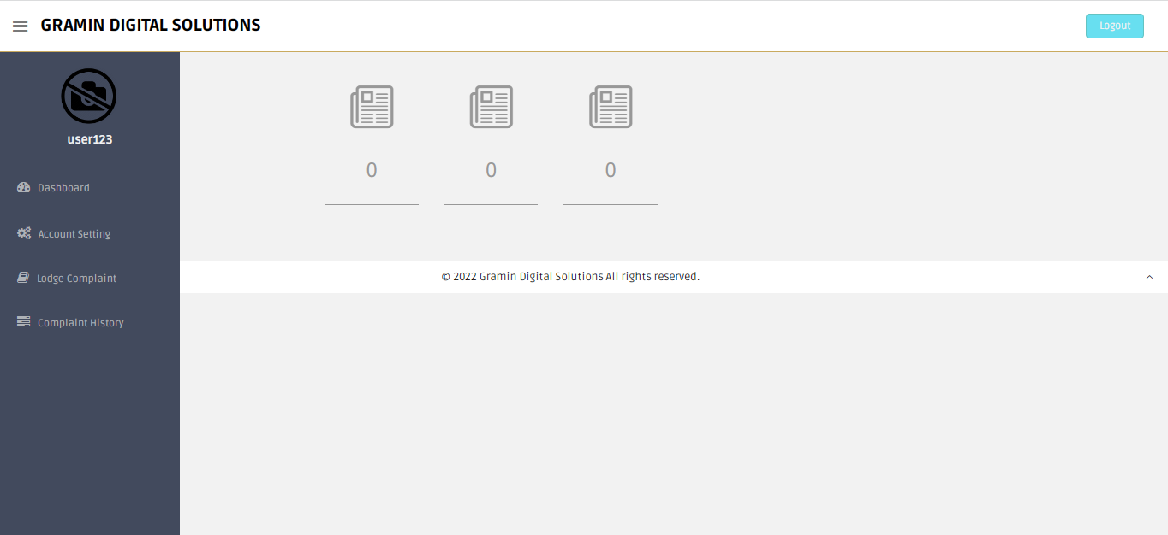

**Register a Complaint (register-complaint.php)**

<?php

session_start();

error_reporting(0);

include('includes/config.php');

if(strlen($_SESSION['login'])==0)

{

header('location:index.php');

}

else{

if(isset($_POST['submit']))

{

$uid=$_SESSION['id'];

$category=$_POST['category'];

$subcat=$_POST['subcategory'];

$complaintype=$_POST['complaintype'];

$state=$_POST['state'];

$noc=$_POST['noc'];

$complaintdetials=$_POST['complaindetails'];

$compfile=$_FILES["compfile"]["name"];

$compvideo=$_FILES["compvideo"]["name"];

$maxsize = 50242880;

move_uploaded_file($_FILES["compfile"]["tmp_name"],"complaintdocs/".$_FILES["compfile"]["name"]);

if(($_FILES['compvideo']['size'] >= $maxsize) || ($_FILES["compvideo"]["size"] == 0)) {

move_uploaded_file($_FILES["compvideo"]["tmp_name"],"videos/".$_FILES["compvideo"]["name"]);

}

else

{

echo "<script>alert('Heelo');<script>";

}

$query=mysqli_query($con,"insert into tblcomplaints(userId,category,subcategory,complaintType,state,noc,complaintDetails,complaintFile,complaintvideo) values('$uid','$category','$subcat','$complaintype','$state','$noc','$complaintdetials','$compfile','$compvideo')");

// code for show complaint number

$sql=mysqli_query($con,"select complaintNumber from tblcomplaints order by complaintNumber desc limit 1");

while($row=mysqli_fetch_array($sql))

{

$cmpn=$row['complaintNumber'];

}

$complainno=$cmpn;

echo '<script> alert("Your complain has been successfully filled and your complaint no is "+"'.$complainno.'")</script>';

}

?>

<!DOCTYPE html>

<html lang="en">

<head>

<meta charset="utf-8">

<meta name="viewport" content="width=device-width, initial-scale=1.0">

<meta name="description" content="">

<meta name="author" content="Dashboard">

<meta name="keyword" content="Dashboard, Bootstrap, Admin, Template, Theme, Responsive, Fluid, Retina">

<title>CMS | User Register Complaint</title>

<!-- Bootstrap core CSS -->

<link href="assets/css/bootstrap.css" rel="stylesheet">

<!--external css-->

<link href="assets/font-awesome/css/font-awesome.css" rel="stylesheet" />

<link rel="stylesheet" type="text/css" href="assets/js/bootstrap-datepicker/css/datepicker.css" />

<link rel="stylesheet" type="text/css" href="assets/js/bootstrap-daterangepicker/daterangepicker.css" />

<link href="assets/css/style.css" rel="stylesheet">

<link href="assets/css/style-responsive.css" rel="stylesheet">

<script>

function getCat(val) {

//alert('val');

$.ajax({

type: "POST",

url: "getsubcat.php",

data:'catid='+val,

success: function(data){

$("#subcategory").html(data);

}

});

}

</script>

</head>

<body>

<section id="container" >

<?php include("includes/header.php");?>

<?php include("includes/sidebar.php");?>

<section id="main-content">

<section class="wrapper">

<h3><i class="fa fa-angle-right"></i> Register Complaint</h3>

<!-- BASIC FORM ELELEMNTS -->

<div class="row mt">

<div class="col-lg-12">

<div class="form-panel">

<?php if($successmsg)

{?>

<div class="alert alert-success alert-dismissable">

<button type="button" class="close" data-dismiss="alert" aria-hidden="true">&times;</button>

<b>Well done!</b> <?php echo htmlentities($successmsg);?></div>

<?php }?>

<?php if($errormsg)

{?>

<div class="alert alert-danger alert-dismissable">

<button type="button" class="close" data-dismiss="alert" aria-hidden="true">&times;</button>

<b>Oh snap!</b> </b> <?php echo htmlentities($errormsg);?></div>

<?php }?>

<form class="form-horizontal style-form" method="post" name="complaint" enctype="multipart/form-data" >

<div class="form-group">

<label class="col-sm-2 col-sm-2 control-label">Category</label>

<div class="col-sm-4">

<select name="category" id="category" class="form-control" onChange="getCat(this.value);" required="">

<option value="">Select Category</option>

<?php $sql=mysqli_query($con,"select id,categoryName from category ");

while ($rw=mysqli_fetch_array($sql)) {

?>

<option value="<?php echo htmlentities($rw['id']);?>"><?php echo htmlentities($rw['categoryName']);?></option>

<?php

}

?>

</select>

</div>

<label class="col-sm-2 col-sm-2 control-label">Sub Category </label>

<div class="col-sm-4">

<select name="subcategory" id="subcategory" class="form-control" >

<option value="">Select Subcategory</option>

</select>

</div>

</div>

<div class="form-group">

<label class="col-sm-2 col-sm-2 control-label">Complaint Type</label>

<div class="col-sm-4">

<select name="complaintype" class="form-control" required="">

<option value=" Complaint"> Complaint</option>

<option value="General Query">General Query</option>

</select>

</div>

<label class="col-sm-2 col-sm-2 control-label">State</label>

<div class="col-sm-4">

<select name="state" required="required" class="form-control">

<option value="">Select State</option>

<?php $sql=mysqli_query($con,"select stateName from state ");

while ($rw=mysqli_fetch_array($sql)) {

?>

<option value="<?php echo htmlentities($rw['stateName']);?>"><?php echo htmlentities($rw['stateName']);?></option>

<?php

}

?>

</select>

</div>

</div>

<div class="form-group">

<label class="col-sm-2 col-sm-2 control-label">Nature of Complaint</label>

<div class="col-sm-4">

<input type="text" name="noc" required="required" value="" required="" class="form-control">

</div>

</div>

<div class="form-group">

<label class="col-sm-2 col-sm-2 control-label">Complaint Details (max 2000 words) </label>

<div class="col-sm-6">

<textarea name="complaindetails" required="required" cols="10" rows="10" class="form-control" maxlength="2000"></textarea>

</div>

</div>

<div class="form-group">

<label class="col-sm-2 col-sm-2 control-label">Complaint Related Doc(if any) </label>

<div class="col-sm-6">

<input type="file" name="compfile" class="form-control" value="">

</div>

</div>

<div class="form-group">

<label class="col-sm-2 col-sm-2 control-label">Complaint Related Video(if any) </label>

<div class="col-sm-6">

<input type="file" name="compvideo" class="form-control" value="">

</div>

</div>

<div class="form-group">

<div class="col-sm-10" style="padding-left:25% ">

<button type="submit" name="submit" class="btn btn-primary">Submit</button>

</div>

</div>

</form>

</div>

</div>

</div>

</section>

</section>

<?php include("includes/footer.php");?>

</section>

<!-- js placed at the end of the document so the pages load faster -->

<script src="assets/js/jquery.js"></script>

<script src="assets/js/bootstrap.min.js"></script>

<script class="include" type="text/javascript" src="assets/js/jquery.dcjqaccordion.2.7.js"></script>

<script src="assets/js/jquery.scrollTo.min.js"></script>

<script src="assets/js/jquery.nicescroll.js" type="text/javascript"></script>

<!--common script for all pages-->

<script src="assets/js/common-scripts.js"></script>

<!--script for this page-->

<script src="assets/js/jquery-ui-1.9.2.custom.min.js"></script>

<!--custom switch-->

<script src="assets/js/bootstrap-switch.js"></script>

<!--custom tagsinput-->

<script src="assets/js/jquery.tagsinput.js"></script>

<!--custom checkbox & radio-->

<script type="text/javascript" src="assets/js/bootstrap-datepicker/js/bootstrap-datepicker.js"></script>

<script type="text/javascript" src="assets/js/bootstrap-daterangepicker/date.js"></script>

<script type="text/javascript" src="assets/js/bootstrap-daterangepicker/daterangepicker.js"></script>

<script type="text/javascript" src="assets/js/bootstrap-inputmask/bootstrap-inputmask.min.js"></script>

<script src="assets/js/form-component.js"></script>

<script>

//custom select box

$(function(){

$('select.styled').customSelect();

});

</script>

</body>

</html>

<?php } ?>

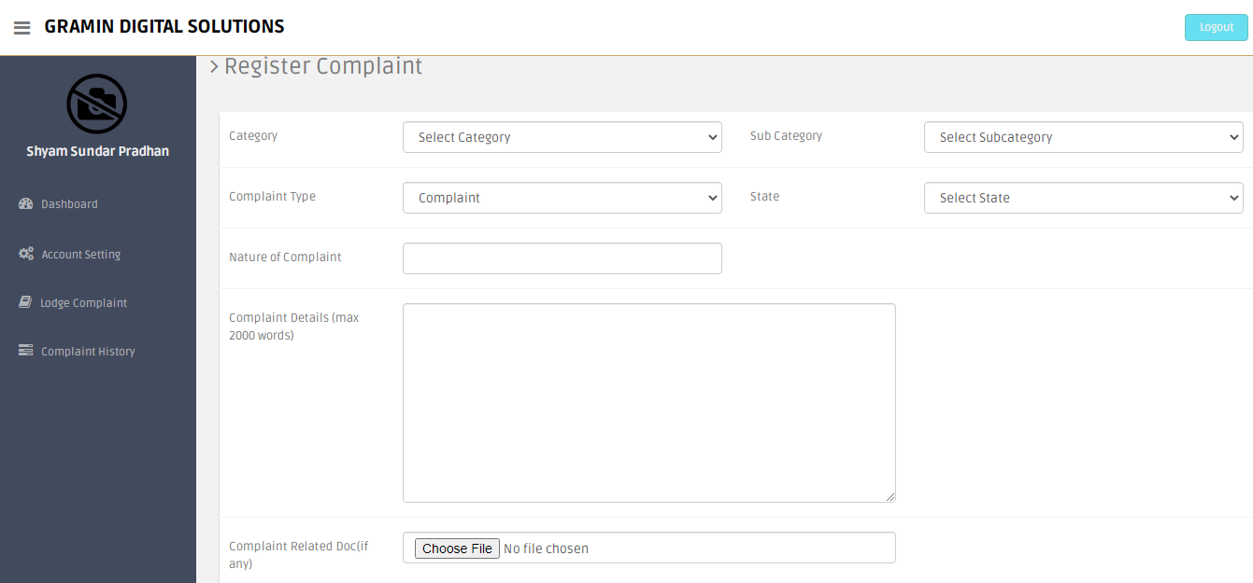

**Complaint History (complaint-history.php)**

<?php

session_start();

error_reporting(0);

include('includes/config.php');

if(strlen($_SESSION['login'])==0)

{

header('location:index.php');

}

else{

?>

<!DOCTYPE html>

<html lang="en">

<head>

<meta charset="utf-8">

<meta name="viewport" content="width=device-width, initial-scale=1.0">

<meta name="description" content="">

<meta name="author" content="Dashboard">

<meta name="keyword" content="Dashboard, Bootstrap, Admin, Template, Theme, Responsive, Fluid, Retina">

<title>CMS | Complaint History</title>

<!-- Bootstrap core CSS -->

<link href="assets/css/bootstrap.css" rel="stylesheet">

<!--external css-->

<link href="assets/font-awesome/css/font-awesome.css" rel="stylesheet" />

<!-- Custom styles for this template -->

<link href="assets/css/style.css" rel="stylesheet">

<link href="assets/css/style-responsive.css" rel="stylesheet">

<link href="assets/css/table-responsive.css" rel="stylesheet">

<!-- HTML5 shim and Respond.js IE8 support of HTML5 elements and media queries -->

<!--[if lt IE 9]>

<script src="https://oss.maxcdn.com/libs/html5shiv/3.7.0/html5shiv.js"></script>

<script src="https://oss.maxcdn.com/libs/respond.js/1.4.2/respond.min.js"></script>

<![endif]-->

</head>

<body>

<section id="container" >

<?php include("includes/header.php");?>

<?php include("includes/sidebar.php");?>

<section id="main-content">

<section class="wrapper">

<h3><i class="fa fa-angle-right"></i>Your Complaint Hstory</h3>

<div class="row mt">

<div class="col-lg-12">

<div class="content-panel">

<section id="unseen">

<table class="table table-bordered table-striped table-condensed">

<thead>

<tr style="text-align: center">

<th style="text-align: center">Complaint Number</th>

<th style="text-align: center">Reg Date</th>

<th style="text-align: center">last Updation date</th>

<th style="text-align: center">Status</th>

<th style="text-align: center">Action</th>

</tr>

</thead>

<tbody>

<?php $query=mysqli_query($con,"select * from tblcomplaints where userId='".$_SESSION['id']."'");

while($row=mysqli_fetch_array($query))

{

?>

<tr>

<td align="center"><?php echo htmlentities($row['complaintNumber']);?></td>

<td align="center"><?php echo htmlentities($row['regDate']);?></td>

<td align="center"><?php echo htmlentities($row['lastUpdationDate']);

?></td>

<td align="center"><?php

$status=$row['status'];

if($status=="" or $status=="NULL")

{ ?>

<button type="button" class="btn btn-theme04">Not Process Yet</button>

<?php }

if($status=="in process"){ ?>

<button type="button" class="btn btn-warning">In Process</button>

<?php }

if($status=="closed") {

?>

<button type="button" class="btn btn-success">Closed</button>

<?php } ?>

<td align="center">

<a href="complaint-details.php?cid=<?php echo htmlentities($row['complaintNumber']);?>">

<button type="button" class="btn btn-primary">View Details</button></a>

</td>

</tr>

<?php } ?>

</tbody>

</table>

</section>

</div><!-- /content-panel -->

</div><!-- /col-lg-4 -->

</div><!-- /row -->

</section><! --/wrapper -->

</section><!-- /MAIN CONTENT -->

<?php include("includes/footer.php");?>

</section>

<!-- js placed at the end of the document so the pages load faster -->

<script src="assets/js/jquery.js"></script>

<script src="assets/js/bootstrap.min.js"></script>

<script class="include" type="text/javascript" src="assets/js/jquery.dcjqaccordion.2.7.js"></script>

<script src="assets/js/jquery.scrollTo.min.js"></script>

<script src="assets/js/jquery.nicescroll.js" type="text/javascript"></script>

<!--common script for all pages-->

<script src="assets/js/common-scripts.js"></script>

<!--script for this page-->

</body>

</html>

<?php } ?>

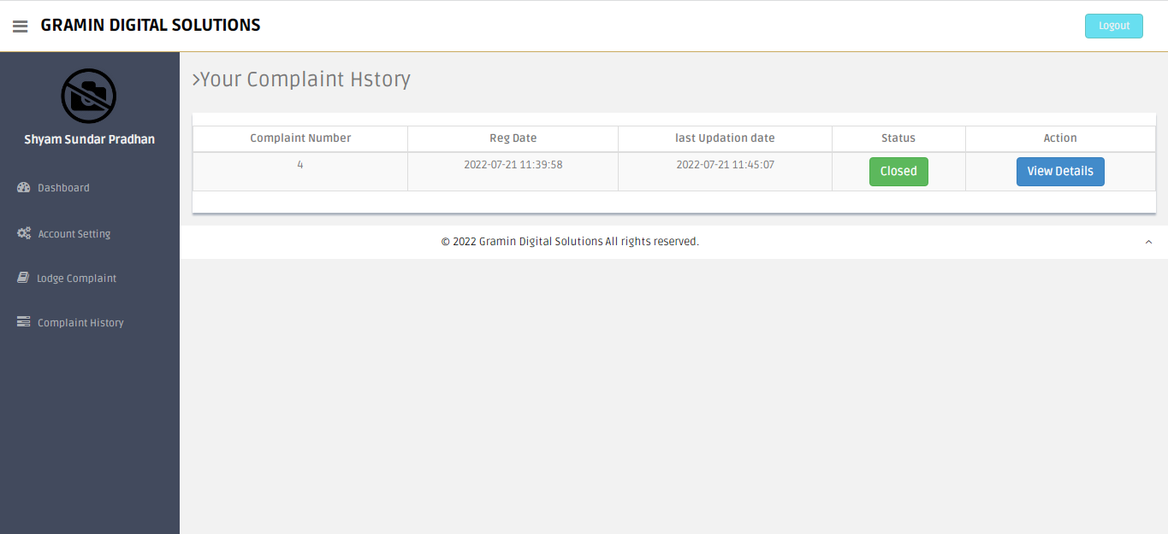

**Complaint Details (complaint-details.php)**

<?php session_start();

error_reporting(0);

include('includes/config.php');

if(strlen($_SESSION['login'])==0)

{

header('location:index.php');

}

else{ ?>

<!DOCTYPE html>

<html lang="en">

<head>

<meta charset="utf-8">

<meta name="viewport" content="width=device-width, initial-scale=1.0">

<meta name="description" content="">

<meta name="author" content="Dashboard">

<meta name="keyword" content="Dashboard, Bootstrap, Admin, Template, Theme, Responsive, Fluid, Retina">

<title>CMS | Complaint Details</title>

<!-- Bootstrap core CSS -->

<link href="assets/css/bootstrap.css" rel="stylesheet">

<link href="assets/font-awesome/css/font-awesome.css" rel="stylesheet" />

<link href="assets/css/style.css" rel="stylesheet">

<link href="assets/css/style-responsive.css" rel="stylesheet">

</head>

<body>

<section id="container" >

<?php include('includes/header.php');?>

<?php include('includes/sidebar.php');?>

<section id="main-content" style="padding-left:5%; color:#000">

<section class="wrapper site-min-height">

<h3><i class="fa fa-angle-right"></i> Complaint Details</h3>

<hr />

<?php $query=mysqli_query($con,"select tblcomplaints.*,category.categoryName as catname from tblcomplaints join category on category.id=tblcomplaints.category where userId='".$_SESSION['id']."' and complaintNumber='".$_GET['cid']."'");

while($row=mysqli_fetch_array($query))

{?>

<div class="row mt">

<label class="col-sm-2 col-sm-2 control-label"><b>Complaint Number : </b></label>

<div class="col-sm-4">

<p><?php echo htmlentities($row['complaintNumber']);?></p>

</div>

<label class="col-sm-2 col-sm-2 control-label"><b>Reg. Date :</b></label>

<div class="col-sm-4">

<p><?php echo htmlentities($row['regDate']);?></p>

</div>

</div>

<div class="row mt">

<label class="col-sm-2 col-sm-2 control-label"><b>Category :</b></label>

<div class="col-sm-4">

<p><?php echo htmlentities($row['catname']);?></p>

</div>

<label class="col-sm-2 col-sm-2 control-label"><b>Sub Category :</b> </label>

<div class="col-sm-4">

<p><?php echo htmlentities($row['subcategory']);?></p>

</div>

</div>

<div class="row mt">

<label class="col-sm-2 col-sm-2 control-label"><b>Complaint Type :</b></label>

<div class="col-sm-4">

<p><?php echo htmlentities($row['complaintType']);?></p>

</div>

<label class="col-sm-2 col-sm-2 control-label"><b>State :</b></label>

<div class="col-sm-4">

<p><?php echo htmlentities($row['state']);?></p>

</div>

</div>

<div class="row mt">

<label class="col-sm-2 col-sm-2 control-label"><b>Nature of Complaint :</b></label>

<div class="col-sm-4">

<p><?php echo htmlentities($row['noc']);?></p>

</div>

<label class="col-sm-2 col-sm-2 control-label"><b>File :</b></label>

<div class="col-sm-4">

<p><?php $cfile=$row['complaintFile'];

if($cfile=="" || $cfile=="NULL")

{

echo htmlentities("File NA");

}

else{ ?>

<a href="complaintdocs/<?php echo htmlentities($row['complaintFile']);?>" target='_blank'> View File</a>

<?php } ?>

</p>

</div>

</div>

<div class="row mt">

<label class="col-sm-2 col-sm-2 control-label"><b>Complaint Details </label>

<div class="col-sm-10">

<p><?php echo htmlentities($row['complaintDetails']);?></p>

</div>

</div>

<?php

$ret=mysqli_query($con,"select complaintremark.remark as remark,complaintremark.status as sstatus,complaintremark.remarkDate as rdate from complaintremark join tblcomplaints on tblcomplaints.complaintNumber=complaintremark.complaintNumber where complaintremark.complaintNumber='".$_GET['cid']."'");

while($rw=mysqli_fetch_array($ret))

{

?>

<div class="row mt">

<label class="col-sm-2 col-sm-2 control-label"><b>Remark:</b></label>

<div class="col-sm-10">

<?php echo htmlentities($rw['remark']); ?>&nbsp;&nbsp; <br /><b>Remark Date: <?php echo htmlentities($rw['rdate']); ?></b>

</div>

</div>

<div class="row mt">

<label class="col-sm-2 col-sm-2 control-label"><b>Status:</b></label>

<div class="col-sm-10">

<?php echo htmlentities($rw['sstatus']); ?>

</div>

</div>

<?php } ?>

<div class="row mt">

<label class="col-sm-2 col-sm-2 control-label"><b>Final Status :</b></label>

<div class="col-sm-4">

<p style="color:red"><?php

if($row['status']=="NULL" || $row['status']=="" )

{

echo "Not Process yet";

} else{

echo htmlentities($row['status']);

}

?></p>

</div>

</div>

<?php } ?>

</section><! --/wrapper -->

</section><!-- /MAIN CONTENT -->

<?php include('includes/footer.php');?>

</section>

<!-- js placed at the end of the document so the pages load faster -->

<script src="assets/js/jquery.js"></script>

<script src="assets/js/bootstrap.min.js"></script>

<script src="assets/js/jquery-ui-1.9.2.custom.min.js"></script>

<script src="assets/js/jquery.ui.touch-punch.min.js"></script>

<script class="include" type="text/javascript" src="assets/js/jquery.dcjqaccordion.2.7.js"></script>

<script src="assets/js/jquery.scrollTo.min.js"></script>

<script src="assets/js/jquery.nicescroll.js" type="text/javascript"></script>

<!--common script for all pages-->

<script src="assets/js/common-scripts.js"></script>

<!--script for this page-->

<script>

//custom select box

$(function(){

$('select.styled').customSelect();

});

</script>

</body>

</html>

<?php } ?>

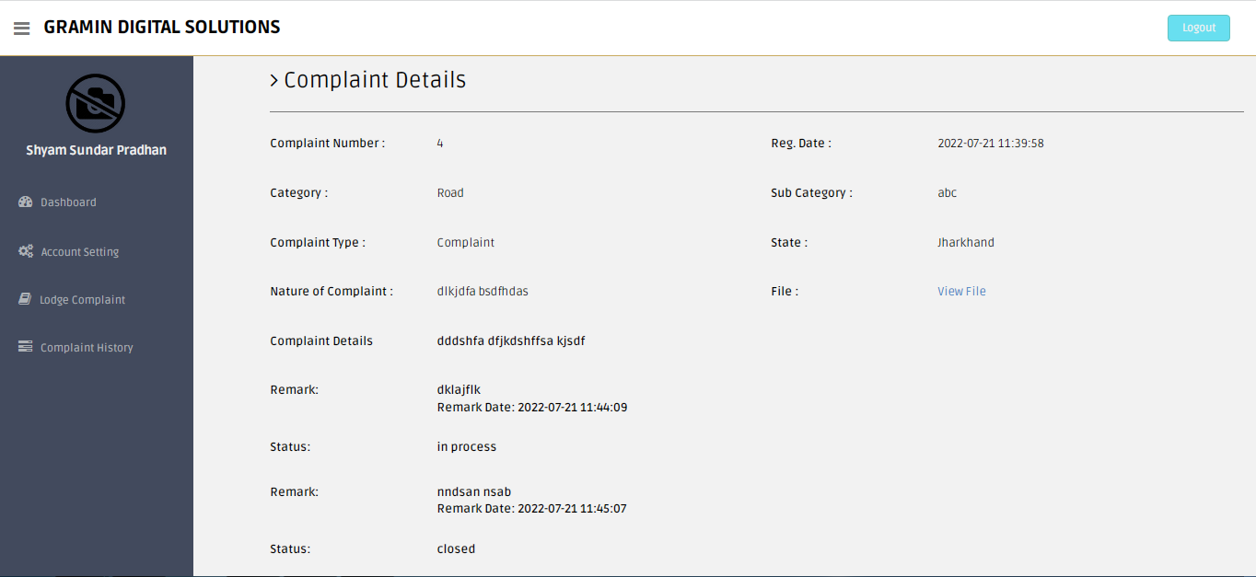

**Profile Info or Update (profile.php)**

<?php

session_start();

error_reporting(0);

include('includes/config.php');

if(strlen($_SESSION['login'])==0)

{

header('location:index.php');

}

else{

date_default_timezone_set('Asia/Kolkata');// change according timezone

$currentTime = date( 'd-m-Y h:i:s A', time () );

if(isset($_POST['submit']))

{

$fname=$_POST['fullname'];

$contactno=$_POST['contactno'];

$address=$_POST['address'];

$state=$_POST['state'];

$country=$_POST['country'];

$pincode=$_POST['pincode'];

$query=mysqli_query($con,"update users set fullName='$fname',contactNo='$contactno',address='$address',State='$state',country='$country',pincode='$pincode' where userEmail='".$_SESSION['login']."'");

if($query)

{

$successmsg="Profile Successfully !!";

}

else

{

$errormsg="Profile not updated !!";

}

}

?>

<!DOCTYPE html>

<html lang="en">

<head>

<meta charset="utf-8">

<meta name="viewport" content="width=device-width, initial-scale=1.0">

<meta name="description" content="">

<meta name="author" content="Dashboard">

<meta name="keyword" content="Dashboard, Bootstrap, Admin, Template, Theme, Responsive, Fluid, Retina">

<title>CMS | User Change Password</title>

<!-- Bootstrap core CSS -->

<link href="assets/css/bootstrap.css" rel="stylesheet">

<!--external css-->

<link href="assets/font-awesome/css/font-awesome.css" rel="stylesheet" />

<link rel="stylesheet" type="text/css" href="assets/js/bootstrap-datepicker/css/datepicker.css" />

<link rel="stylesheet" type="text/css" href="assets/js/bootstrap-daterangepicker/daterangepicker.css" />

<link href="assets/css/style.css" rel="stylesheet">

<link href="assets/css/style-responsive.css" rel="stylesheet">

</head>

<body>

<section id="container" >

<?php include("includes/header.php");?>

<?php include("includes/sidebar.php");?>

<section id="main-content">

<section class="wrapper">

<h3><i class="fa fa-angle-right"></i> Profile info</h3>

<!-- BASIC FORM ELELEMNTS -->

<div class="row mt">

<div class="col-lg-12">

<div class="form-panel">

<?php if($successmsg)

{?>

<div class="alert alert-success alert-dismissable">

<button type="button" class="close" data-dismiss="alert" aria-hidden="true">&times;</button>

<b>Well done!</b> <?php echo htmlentities($successmsg);?></div>

<?php }?>

<?php if($errormsg)

{?>

<div class="alert alert-danger alert-dismissable">

<button type="button" class="close" data-dismiss="alert" aria-hidden="true">&times;</button>

<b>Oh snap!</b> </b> <?php echo htmlentities($errormsg);?></div>

<?php }?>

<?php $query=mysqli_query($con,"select * from users where userEmail='".$_SESSION['login']."'");

while($row=mysqli_fetch_array($query))

{

?>

<h4 class="mb"><i class="fa fa-user"></i>&nbsp;&nbsp;<?php echo htmlentities($row['fullName']);?>'s Profile</h4>

<h5><b>Last Updated at :</b>&nbsp;&nbsp;<?php echo htmlentities($row['updationDate']);?></h5>

<form class="form-horizontal style-form" method="post" name="profile" >

<div class="form-group">

<label class="col-sm-2 col-sm-2 control-label">Full Name</label>

<div class="col-sm-4">

<input type="text" name="fullname" required="required" value="<?php echo htmlentities($row['fullName']);?>" class="form-control" >

</div>

<label class="col-sm-2 col-sm-2 control-label">User Email </label>

<div class="col-sm-4">

<input type="email" name="useremail" required="required" value="<?php echo htmlentities($row['userEmail']);?>" class="form-control" readonly>

</div>

</div>

<div class="form-group">

<label class="col-sm-2 col-sm-2 control-label">Contact</label>

<div class="col-sm-4">

<input type="text" name="contactno" required="required" value="<?php echo htmlentities($row['contactNo']);?>" class="form-control">

</div>

<label class="col-sm-2 col-sm-2 control-label">Address </label>

<div class="col-sm-4">

<textarea name="address" required="required" class="form-control"><?php echo htmlentities($row['address']);?></textarea>

</div>

</div>

<div class="form-group">

<label class="col-sm-2 col-sm-2 control-label">State</label>

<div class="col-sm-4">

<select name="state" required="required" class="form-control">

<option value="<?php echo htmlentities($row['State']);?>"><?php echo htmlentities($st=$row['State']);?></option>

<?php $sql=mysqli_query($con,"select stateName from state ");

while ($rw=mysqli_fetch_array($sql)) {

if($rw['stateName']==$st)

{

continue;

}

else

{

?>

<option value="<?php echo htmlentities($rw['stateName']);?>"><?php echo htmlentities($rw['stateName']);?></option>

<?php

}}

?>

</select>

</div>

<label class="col-sm-2 col-sm-2 control-label">Country </label>

<div class="col-sm-4">

<input type="text" name="country" required="required" value="<?php echo htmlentities($row['country']);?>" class="form-control">

</div>

</div>

<div class="form-group">

<label class="col-sm-2 col-sm-2 control-label">Pincode</label>

<div class="col-sm-4">

<input type="text" name="pincode" maxlength="6" required="required" value="<?php echo htmlentities($row['pincode']);?>" class="form-control">

</div>

<label class="col-sm-2 col-sm-2 control-label">Reg Date </label>

<div class="col-sm-4">

<input type="text" name="regdate" required="required" value="<?php echo htmlentities($row['regDate']);?>" class="form-control" readonly>

</div>

</div>

<div class="form-group">

<label class="col-sm-2 col-sm-2 control-label">User Photo</label>

<div class="col-sm-4">

<?php $userphoto=$row['userImage'];

if($userphoto==""):

?>

<img src="userimages/noimage.png" width="256" height="256" >

<a href="update-image.php">Change Photo</a>

<?php else:?>

<img src="userimages/<?php echo htmlentities($userphoto);?>" width="256" height="256">

<a href="update-image.php">Change Photo</a>

<?php endif;?>

</div>

</div>

<?php } ?>

<div class="form-group">

<div class="col-sm-10" style="padding-left:25% ">

<button type="submit" name="submit" class="btn btn-primary">Submit</button>

</div>

</div>

</form>

</div>

</div>

</div>

</section>

</section>

<?php include("includes/footer.php");?>

</section>

<!-- js placed at the end of the document so the pages load faster -->

<script src="assets/js/jquery.js"></script>

<script src="assets/js/bootstrap.min.js"></script>

<script class="include" type="text/javascript" src="assets/js/jquery.dcjqaccordion.2.7.js"></script>

<script src="assets/js/jquery.scrollTo.min.js"></script>

<script src="assets/js/jquery.nicescroll.js" type="text/javascript"></script>

<!--common script for all pages-->

<script src="assets/js/common-scripts.js"></script>

<!--script for this page-->

<script src="assets/js/jquery-ui-1.9.2.custom.min.js"></script>

<!--custom switch-->

<script src="assets/js/bootstrap-switch.js"></script>

<!--custom tagsinput-->

<script src="assets/js/jquery.tagsinput.js"></script>

<!--custom checkbox & radio-->

<script type="text/javascript" src="assets/js/bootstrap-datepicker/js/bootstrap-datepicker.js"></script>

<script type="text/javascript" src="assets/js/bootstrap-daterangepicker/date.js"></script>

<script type="text/javascript" src="assets/js/bootstrap-daterangepicker/daterangepicker.js"></script>

<script type="text/javascript" src="assets/js/bootstrap-inputmask/bootstrap-inputmask.min.js"></script>

<script src="assets/js/form-component.js"></script>

<script>

//custom select box

$(function(){

$('select.styled').customSelect();

});

</script>

</body>

</html>

<?php } ?>

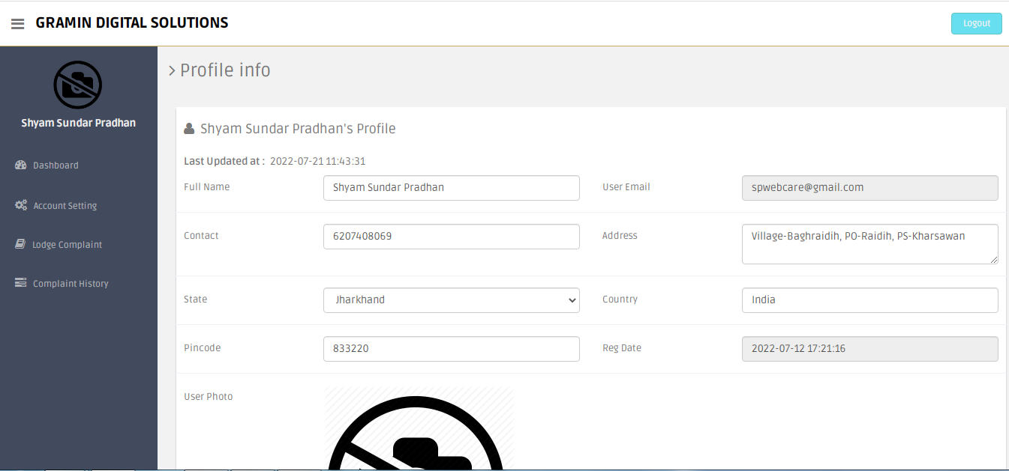

**User change password (change-password.php)**

<?php

session_start();

error_reporting(0);

include('includes/config.php');

if(strlen($_SESSION['login'])==0)

{

header('location:index.php');

}

else{

date_default_timezone_set('Asia/Kolkata');// change according timezone

$currentTime = date( 'd-m-Y h:i:s A', time () );

if(isset($_POST['submit']))

{

$sql=mysqli_query($con,"SELECT password FROM users where password='".md5($_POST['password'])."' && userEmail='".$_SESSION['login']."'");

$num=mysqli_fetch_array($sql);

if($num>0)

{

$con=mysqli_query($con,"update users set password='".md5($_POST['newpassword'])."', updationDate='$currentTime' where userEmail='".$_SESSION['login']."'");

$successmsg="Password Changed Successfully !!";

}

else

{

$errormsg="Old Password not match !!";

}

}

?>

<!DOCTYPE html>

<html lang="en">

<head>

<meta charset="utf-8">

<meta name="viewport" content="width=device-width, initial-scale=1.0">

<meta name="description" content="">

<meta name="author" content="Dashboard">

<meta name="keyword" content="Dashboard, Bootstrap, Admin, Template, Theme, Responsive, Fluid, Retina">

<title>CMS | User Change Password</title>

<!-- Bootstrap core CSS -->

<link href="assets/css/bootstrap.css" rel="stylesheet">

<!--external css-->

<link href="assets/font-awesome/css/font-awesome.css" rel="stylesheet" />

<link rel="stylesheet" type="text/css" href="assets/js/bootstrap-datepicker/css/datepicker.css" />

<link rel="stylesheet" type="text/css" href="assets/js/bootstrap-daterangepicker/daterangepicker.css" />

<link href="assets/css/style.css" rel="stylesheet">

<link href="assets/css/style-responsive.css" rel="stylesheet">

<script type="text/javascript">

function valid()

{

if(document.chngpwd.password.value=="")

{

alert("Current Password Filed is Empty !!");

document.chngpwd.password.focus();

return false;

}

else if(document.chngpwd.newpassword.value=="")

{

alert("New Password Filed is Empty !!");

document.chngpwd.newpassword.focus();

return false;

}

else if(document.chngpwd.confirmpassword.value=="")

{

alert("Confirm Password Filed is Empty !!");

document.chngpwd.confirmpassword.focus();

return false;

}

else if(document.chngpwd.newpassword.value!= document.chngpwd.confirmpassword.value)

{

alert("Password and Confirm Password Field do not match !!");

document.chngpwd.confirmpassword.focus();

return false;

}

return true;

}

</script>

</head>

<body>

<section id="container" >

<?php include("includes/header.php");?>

<?php include("includes/sidebar.php");?>

<section id="main-content">

<section class="wrapper">

<h3><i class="fa fa-angle-right"></i> Change Password</h3>

<!-- BASIC FORM ELELEMNTS -->

<div class="row mt">

<div class="col-lg-12">

<div class="form-panel">

<h4 class="mb"><i class="fa fa-angle-right"></i> User Change Password</h4>

<?php if($successmsg)

{?>

<div class="alert alert-success alert-dismissable">

<button type="button" class="close" data-dismiss="alert" aria-hidden="true">&times;</button>

<b>Well done!</b> <?php echo htmlentities($successmsg);?></div>

<?php }?>

<?php if($errormsg)

{?>

<div class="alert alert-danger alert-dismissable">

<button type="button" class="close" data-dismiss="alert" aria-hidden="true">&times;</button>

<b>Oh snap!</b> </b> <?php echo htmlentities($errormsg);?></div>

<?php }?>

<form class="form-horizontal style-form" method="post" name="chngpwd" onSubmit="return valid();">

<div class="form-group">

<label class="col-sm-2 col-sm-2 control-label">Current Password</label>

<div class="col-sm-10">

<input type="password" name="password" required="required" class="form-control">

</div>

</div>

<div class="form-group">

<label class="col-sm-2 col-sm-2 control-label">New Password</label>

<div class="col-sm-10">

<input type="password" name="newpassword" required="required" class="form-control">

</div>

</div>

<div class="form-group">

<label class="col-sm-2 col-sm-2 control-label">Confirm Password</label>

<div class="col-sm-10">

<input type="password" name="confirmpassword" required="required" class="form-control">

</div>

</div>

<div class="form-group">

<div class="col-sm-10" style="padding-left:25% ">

<button type="submit" name="submit" class="btn btn-primary">Submit</button>

</div>

</div>

</form>

</div>

</div>

</div>

</section><! --/wrapper -->

</section><!-- /MAIN CONTENT -->

<?php include("includes/footer.php");?>

</section>

<!-- js placed at the end of the document so the pages load faster -->

<script src="assets/js/jquery.js"></script>

<script src="assets/js/bootstrap.min.js"></script>

<script class="include" type="text/javascript" src="assets/js/jquery.dcjqaccordion.2.7.js"></script>

<script src="assets/js/jquery.scrollTo.min.js"></script>

<script src="assets/js/jquery.nicescroll.js" type="text/javascript"></script>

<!--common script for all pages-->

<script src="assets/js/common-scripts.js"></script>

<!--script for this page-->

<script src="assets/js/jquery-ui-1.9.2.custom.min.js"></script>

<!--custom switch-->

<script src="assets/js/bootstrap-switch.js"></script>

<!--custom tagsinput-->

<script src="assets/js/jquery.tagsinput.js"></script>

<!--custom checkbox & radio-->

<script type="text/javascript" src="assets/js/bootstrap-datepicker/js/bootstrap-datepicker.js"></script>

<script type="text/javascript" src="assets/js/bootstrap-daterangepicker/date.js"></script>

<script type="text/javascript" src="assets/js/bootstrap-daterangepicker/daterangepicker.js"></script>

<script type="text/javascript" src="assets/js/bootstrap-inputmask/bootstrap-inputmask.min.js"></script>

<script src="assets/js/form-component.js"></script>

<script>

//custom select box

$(function(){

$('select.styled').customSelect();

});

</script>

</body>

</html>

<?php } ?>

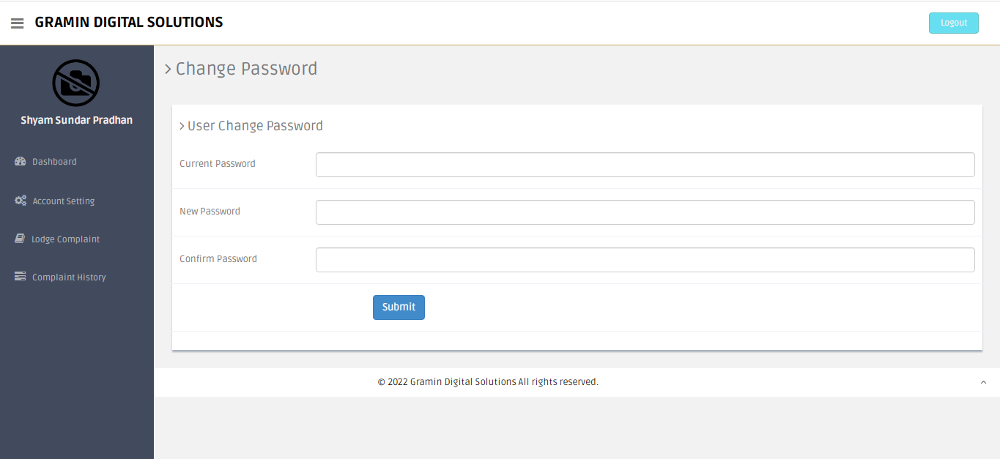

**Admin add notification (notification.php)**

<?php

session_start();

include('include/config.php');

if(strlen($_SESSION['alogin'])==0)

{

header('location:index.php');

}

else{

date_default_timezone_set('Asia/Kolkata');// change according timezone

$currentTime = date( 'd-m-Y h:i:s A', time () );

if(isset($_POST['submit']))

{

$state=$_POST['state'];

$description=$_POST['description'];

$sql=mysqli_query($con,"insert into notifi(heading,description) values('$state','$description')");

$_SESSION['msg']="Notification added Successfully !!";

}

if(isset($_GET['del']))

{

mysqli_query($con,"delete from notifi where id = '".$_GET['id']."'");

$_SESSION['delmsg']="Notification deleted !!";

}

?>

<!DOCTYPE html>

<html lang="en">

<head>

<meta http-equiv="Content-Type" content="text/html; charset=utf-8" />

<meta name="viewport" content="width=device-width, initial-scale=1.0">

<title>Admin| Notification</title>

<link type="text/css" href="bootstrap/css/bootstrap.min.css" rel="stylesheet">

<link type="text/css" href="bootstrap/css/bootstrap-responsive.min.css" rel="stylesheet">

<link type="text/css" href="css/theme.css" rel="stylesheet">

<link type="text/css" href="images/icons/css/font-awesome.css" rel="stylesheet">

<link type="text/css" href='http://fonts.googleapis.com/css?family=Open+Sans:400italic,600italic,400,600' rel='stylesheet'>

</head>

<body>

<?php include('include/header.php');?>

<div class="wrapper">

<div class="container">

<div class="row">

<?php include('include/sidebar.php');?>

<div class="span9">

<div class="content">

<div class="module">

<div class="module-head">

<h3>Notification</h3>

</div>

<div class="module-body">

<?php if(isset($_POST['submit']))

{?>

<div class="alert alert-success">

<button type="button" class="close" data-dismiss="alert">×</button>

<strong>Well done!</strong> <?php echo htmlentities($_SESSION['msg']);?><?php echo htmlentities($_SESSION['msg']="");?>

</div>

<?php } ?>

<?php if(isset($_GET['del']))

{?>

<div class="alert alert-error">

<button type="button" class="close" data-dismiss="alert">×</button>

<strong>Oh snap!</strong> <?php echo htmlentities($_SESSION['delmsg']);?><?php echo htmlentities($_SESSION['delmsg']="");?>

</div>

<?php } ?>

<br />

<form class="form-horizontal row-fluid" name="Category" method="post" >

<div class="control-group">

<label class="control-label" for="basicinput">Notification Heading</label>

<div class="controls">

<input type="text" placeholder="Enter Heading" name="state" class="span8 tip" required>

</div>

</div>

<div class="control-group">

<label class="control-label" for="basicinput">Description</label>

<div class="controls">

<textarea class="span8" name="description" rows="5"></textarea>

</div>

</div>

<div class="control-group">

<div class="controls">

<button type="submit" name="submit" class="btn">Create</button>

</div>

</div>

</form>

</div>

</div>

<div class="module">

<div class="module-head">

<h3>Manage Notification</h3>

</div>

<div class="module-body table">

<table cellpadding="0" cellspacing="0" border="0" class="datatable-1 table table-bordered table-striped display" width="100%">

<thead>

<tr>

<th>#</th>

<th>Heading</th>

<th>Description</th>

<th>Post date</th>

<th>Action</th>

</tr>

</thead>

<tbody>

<?php $query=mysqli_query($con,"select * from notifi");

$cnt=1;

while($row=mysqli_fetch_array($query))

{

?>

<tr>

<td><?php echo htmlentities($cnt);?></td>

<td><?php echo htmlentities($row['heading']);?></td>

<td><?php echo htmlentities($row['description']);?></td>

<td> <?php echo htmlentities($row['dop']);?></td> <td> <a href="notification.php?id=<?php echo $row['id']?>&del=delete" onClick="return confirm('Are you sure you want to delete?')"><i class="icon-remove-sign"></i></a></td> </tr> <?php $cnt=$cnt+1; } ?>

</table>

</div>

</div>

</div><!--/.content-->

</div><!--/.span9-->

</div>

</div><!--/.container-->

</div><!--/.wrapper-->

<?php include('include/footer.php');?>

<script src="scripts/jquery-1.9.1.min.js" type="text/javascript"></script>

<script src="scripts/jquery-ui-1.10.1.custom.min.js" type="text/javascript"></script>

<script src="bootstrap/js/bootstrap.min.js" type="text/javascript"></script>

<script src="scripts/flot/jquery.flot.js" type="text/javascript"></script>

<script src="scripts/datatables/jquery.dataTables.js"></script>

<script>

$(document).ready(function() {

$('.datatable-1').dataTable();

$('.dataTables_paginate').addClass("btn-group datatable-pagination");

$('.dataTables_paginate > a').wrapInner('<span />');

$('.dataTables_paginate > a:first-child').append('<i class="icon-chevron-left shaded"></i>');

$('.dataTables_paginate > a:last-child').append('<i class="icon-chevron-right shaded"></i>');

} );

</script>

</body>

<?php } ?>

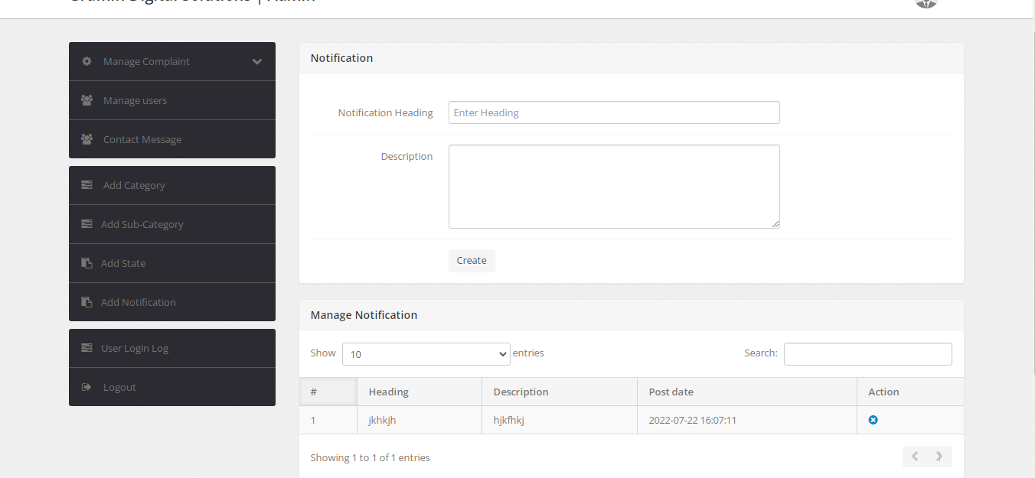

**Contact Message (contact-message.php)**

<?php

session_start();

include('include/config.php');

if(strlen($_SESSION['alogin'])==0)

{

header('location:index.php');

}

else{

date_default_timezone_set('Asia/Kolkata');// change according timezone

$currentTime = date( 'd-m-Y h:i:s A', time () );

?>

<!DOCTYPE html>

<html lang="en">

<head>

<meta http-equiv="Content-Type" content="text/html; charset=utf-8" />

<meta name="viewport" content="width=device-width, initial-scale=1.0">

<title>Admin| Contact Message</title>

<link type="text/css" href="bootstrap/css/bootstrap.min.css" rel="stylesheet">

<link type="text/css" href="bootstrap/css/bootstrap-responsive.min.css" rel="stylesheet">

<link type="text/css" href="css/theme.css" rel="stylesheet">

<link type="text/css" href="images/icons/css/font-awesome.css" rel="stylesheet">

<link type="text/css" href='http://fonts.googleapis.com/css?family=Open+Sans:400italic,600italic,400,600' rel='stylesheet'>

</head>

<body>

<?php include('include/header.php');?>

<div class="wrapper">

<div class="container">

<div class="row">

<?php include('include/sidebar.php');?>

<div class="span9">

<div class="content">

<div class="module">

<div class="module-head">

<h3>Contact Message</h3>

</div>

<div class="module-body">

<table class="table"> <tr> <th>Name</th> <th>Mobile Number</th> <th>Email ID</th> <th>Subject</th> <th>Message</th> </tr> <?php $se=mysqli_query($con,"select *from contact order by id desc");

while($se1=mysqli_fetch_assoc($se)){ ?>

<td><?php echo $se1['name']; ?></td> <td><?php echo $se1['mobile']; ?></td> <td><?php echo $se1['email']; ?></td>

<td><?php echo $se1['subject']; ?></td>

<td><?php echo $se1['message']; ?></td>

<?php

}

?>

</table>

</div>

</div></div><!--/.content-->

</div><!--/.span9-->

</div>

</div><!--/.container-->

</div><!--/.wrapper-->

<?php include('include/footer.php');?>

<script src="scripts/jquery-1.9.1.min.js" type="text/javascript"></script>

<script src="scripts/jquery-ui-1.10.1.custom.min.js" type="text/javascript"></script>

<script src="bootstrap/js/bootstrap.min.js" type="text/javascript"></script>

<script src="scripts/flot/jquery.flot.js" type="text/javascript"></script>

</body>

<?php } ?>

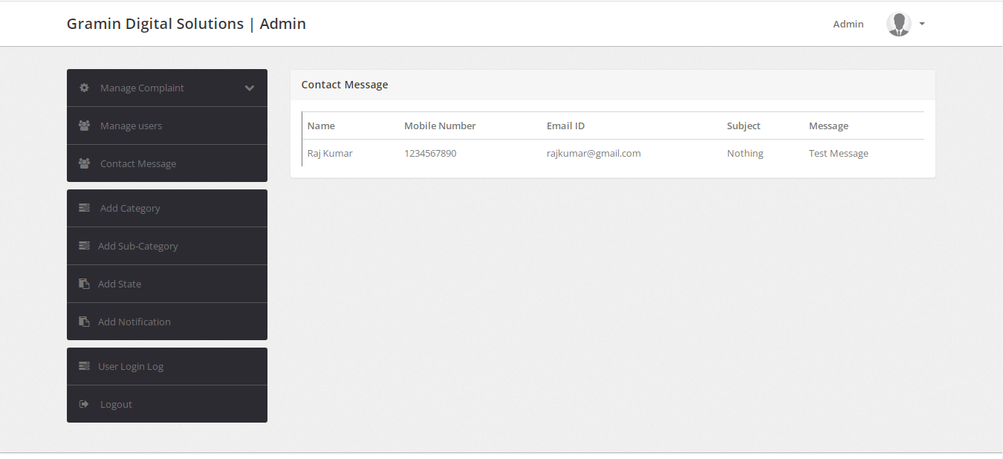

**Add State (state.php)**

<?php

session_start();

include('include/config.php');

if(strlen($_SESSION['alogin'])==0)

{

header('location:index.php');

}

else{

date_default_timezone_set('Asia/Kolkata');// change according timezone

$currentTime = date( 'd-m-Y h:i:s A', time () );

if(isset($_POST['submit']))

{

$state=$_POST['state'];

$description=$_POST['description'];

$sql=mysqli_query($con,"insert into state(stateName,stateDescription) values('$state','$description')");

$_SESSION['msg']="State added Successfully !!";

}

if(isset($_GET['del']))

{

mysqli_query($con,"delete from state where id = '".$_GET['id']."'");

$_SESSION['delmsg']="State deleted !!";

}

?>

<!DOCTYPE html>

<html lang="en">

<head>

<meta http-equiv="Content-Type" content="text/html; charset=utf-8" />

<meta name="viewport" content="width=device-width, initial-scale=1.0">

<title>Admin| State</title>

<link type="text/css" href="bootstrap/css/bootstrap.min.css" rel="stylesheet">

<link type="text/css" href="bootstrap/css/bootstrap-responsive.min.css" rel="stylesheet">

<link type="text/css" href="css/theme.css" rel="stylesheet">

<link type="text/css" href="images/icons/css/font-awesome.css" rel="stylesheet">

<link type="text/css" href='http://fonts.googleapis.com/css?family=Open+Sans:400italic,600italic,400,600' rel='stylesheet'>

</head>

<body>

<?php include('include/header.php');?>

<div class="wrapper">

<div class="container">

<div class="row">

<?php include('include/sidebar.php');?>

<div class="span9">

<div class="content">

<div class="module">

<div class="module-head">

<h3>State</h3>

</div>

<div class="module-body">

<?php if(isset($_POST['submit']))

{?>

<div class="alert alert-success">

<button type="button" class="close" data-dismiss="alert">×</button>

<strong>Well done!</strong> <?php echo htmlentities($_SESSION['msg']);?><?php echo htmlentities($_SESSION['msg']="");?>

</div>

<?php } ?>

<?php if(isset($_GET['del']))

{?>

<div class="alert alert-error">

<button type="button" class="close" data-dismiss="alert">×</button>

<strong>Oh snap!</strong> <?php echo htmlentities($_SESSION['delmsg']);?><?php echo htmlentities($_SESSION['delmsg']="");?>

</div>

<?php } ?>

<br />

<form class="form-horizontal row-fluid" name="Category" method="post" >

<div class="control-group">

<label class="control-label" for="basicinput">State Name</label>

<div class="controls">

<input type="text" placeholder="Enter State Name" name="state" class="span8 tip" required>

</div>

</div>

<div class="control-group">

<label class="control-label" for="basicinput">Description</label>

<div class="controls">

<textarea class="span8" name="description" rows="5"></textarea>

</div>

</div>

<div class="control-group">

<div class="controls">

<button type="submit" name="submit" class="btn">Create</button>

</div>

</div>

</form>

</div>

</div>

<div class="module">

<div class="module-head">

<h3>Manage States</h3>

</div>

<div class="module-body table">

<table cellpadding="0" cellspacing="0" border="0" class="datatable-1 table table-bordered table-striped display" width="100%">

<thead>

<tr> <th>#</th> <th>State</th>

<th>Description</th> <th>Creation date</th> <th>Last Updated</th>

<th>Action</th> </tr> </thead> <tbody>

<?php $query=mysqli_query($con,"select * from state");

$cnt=1;

while($row=mysqli_fetch_array($query))

{

?>

<tr><td><?php echo htmlentities($cnt);?></td>

<td><?php echo htmlentities($row['stateName']);?></td>

<td><?php echo htmlentities($row['stateDescription']);?></td>

<td> <?php echo htmlentities($row['postingDate']);?></td>

<td><?php echo htmlentities($row['updationDate']);?></td>

<td>

<a href="edit-state.php?id=<?php echo $row['id']?>" ><i class="icon-edit"></i></a>

<a href="state.php?id=<?php echo $row['id']?>&del=delete" onClick="return confirm('Are you sure you want to delete?')"><i class="icon-remove-sign"></i></a></td>

</tr> <?php $cnt=$cnt+1; } ?>

</table>

</div>

</div>

</div><!--/.content-->

</div><!--/.span9-->

</div>

</div><!--/.container-->

</div><!--/.wrapper-->

<?php include('include/footer.php');?>

<script src="scripts/jquery-1.9.1.min.js" type="text/javascript"></script>

<script src="scripts/jquery-ui-1.10.1.custom.min.js" type="text/javascript"></script>

<script src="bootstrap/js/bootstrap.min.js" type="text/javascript"></script>

<script src="scripts/flot/jquery.flot.js" type="text/javascript"></script>

<script src="scripts/datatables/jquery.dataTables.js"></script>

<script>

$(document).ready(function() {

$('.datatable-1').dataTable();

$('.dataTables_paginate').addClass("btn-group datatable-pagination");

$('.dataTables_paginate > a').wrapInner('<span />');

$('.dataTables_paginate > a:first-child').append('<i class="icon-chevron-left shaded"></i>');

$('.dataTables_paginate > a:last-child').append('<i class="icon-chevron-right shaded"></i>');

} );

</script>

</body>

<?php } ?>

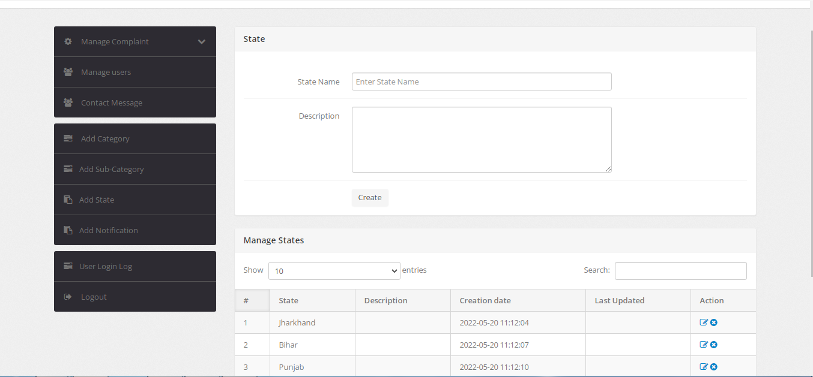

**CHAPTER 6 :**

**CONCLUSION**

**6.1 Conclusion**

This software will be useful to any school/college hostel or in general to any institute maintaining a mess or canteen. Security is maintained as the complete control of the system is only under the hands of an authorized person. It will enable tiffin system managers to refer diet charts and plan healthy, nutritious diet accordingly for the cadets. Also, this system will enable Stock purchasing based on daily fluctuating rates. Since easy calculations and bill generations are done in minutes, therefore, it will lessen the work/load of tiffin system managers. Using this software, alerts regarding the stock of commodities will be easily generated. It will never let scarcity prevail in the mess. Backup of data can be easily taken using this software on the click of a single button. Restoring the data back to the system is also possible in case of any failure. Also, this software will reduce manpower, thus reducing the capital being invested. This project can be merged with any major projects in future where meals and their monthly calculations need to be done.

**6.2 Future scope:**

1. Government's services are made available to citizens electronically by improved online infrastructure and by increasing Internet connectivity or making the country digitally empowered in the field of technology
2. It consists of three core components: the development of secure and stable digital infrastructure, delivering government services digitally, and universal digital literacy.
3. The Digital India is a programme of the Government of India with a vision to transform India into a digitally empowered society and knowledge economy.
4. The goal of Digital Villages is to strengthen the feeling of togetherness within the local community by enabling new forms of voluntary participation and enhancing local sourcing of goods and services.

**6.3 Limitation of project**

Project management software costs money. And for some companies, the price tag may be a reason why they hold off from switching to project management software. Apart from the costs of the software, its implementation and maintenance cost money too. And some products are often sold with different modules that may make them more expensive. While project management software is meant to help companies organize things and streamline

learning curve that needs to be taken into consideration.

The latest versions of online project management solutions enable access for multiple users. This makes sharing of data much easier. However, while multi- user access has its collaborative benefits, you will need to avoid unauthorized viewing of sensitive project data and monitor access control. Forget to change the settings in access control, and you could have many eyes viewing private company information.

If you and your team are using project likely making the transition from traditional spreadsheets. The thing is, project management software should be easy-to-use. Entry Software knew how crucial it was to create a solution that resulted in bet why their Team Headquarters Project Management application has a simple-to-use interface that can control 100% of project interactions.

**CHAPTER 7 :**

**BIBLIOGRAPGY**

<https://www.w3schools.com/>

<https://stackoverflow.com/>

<https://github.com/>

<https://www.php.net/>

<https://www.javatpoint.com/>

<https://www.geeksforgeeks.org/>